

Human Computer Interaction – 5CS020

Design and Usability Testing Report

**Student ID:** 2332244

**Student Name:** Naomi Thing

**Group:** L5CG4

**Module Leader:** Mr. Dipesh Shrestha

**Tutor:** Ms. Nerisha Shrestha

**Submitted on:** 19th may, 2024.

**Table of Contents**

1. Introduction to ComicZone: 1

2. The Design Processes: 2

2.1 User Persona 3

2.2 User Stories 5

2.3 User flow and Task flow: 8

2.4 Brainstorm 9

2.5 Lo-Fi Wireframes: 10

2.6 Wire flow: 19

2.7 Mood board: 19

3. Evaluation and Testing 20

3.1 Evaluation methodologies: 20

3.2 Usability and Accessibility. 21

3.2.1 Strive for consistency || Consistency and Standards. 21

3.2.2 Enable frequent users to use shortcuts || Flexibility and efficiency of use. 22

3.2.3 Offer Informative Feedback || Design dialogue to yield closure || Visibility of system Status. 23

3.2.4 Reduce short-term memory load || Recognition rather than recall. 24

3.2.5 Support internal locus of control || Permit easy reversal of action || User control and freedom. 25

3.2.6 Offer simple error handling || Help users recognize, diagnose, and recover from errors. 26

3.2.7 Error Prevention (Nielsen’s Heuristics) 28

3.2.8 Aesthetic and minimalist design (Nielsen’s Heuristics) 29

3.2.9 Match Between System and Real World (Nielsen’s Heuristics) 29

3.2.10 Help and Documentation 30

3.3 Usability and Accessibility Issues uncovered. 31

3.3.1 Usability Issue: 31

3.3.2 Accessibility Issue: 32

3.4 List of question for User testing: 32

3.4.1 Personal Questions: 33

3.4.2 Questions related to Schneiderman’s 8 Golden rules and Nielsen’s Heuristics: 33

3.4.3 Questions related to the Accessibility. 34

3.5 User Testing and Testing Analysis: 34

3.5.1 Reviews of Users on testing: 34

3.6 Revamp Design 37

3.6.1 Documentation for Privacy in Home page: 37

3.6.2 Change in Font size using typography plugin: 37

4. Conclusion 38

5. Appendix 38

5.1 Screenshot of Questionnaires: 38

5.2 Screenshots of Design of ComicZone: 46

5.3 Screenshot of Lo-Fi wireframes of ComicZone: 68

5.4 Prototype of ComicZone 74

**Table of Figures:**

Figure 1ComicZone 1

Figure 2User Persona 1 3

Figure 3User Persona 2 4

Figure 4User Persona 3 4

Figure 5 User stories 1 6

Figure 6 User stories 2 7

Figure 7 User stories 3 8

Figure 8 User flow and task flow 9

Figure 9 brain storming of ComicZone 10

Figure 10 login 11

Figure 11 home 12

Figure 12 genres 13

Figure 13 popular 14

Figure 14 publish 15

Figure 15 review 16

Figure 16 chapter review 17

Figure 17 comment 18

Figure 18 wireflow 19

Figure 19 mood board of ComicZone 20

Figure 20 rule 1 21

Figure 21 rule 2 22

Figure 22 rule 2 22

Figure 23 rule 3 23

Figure 24 rule 4 24

Figure 25 rule 5 25

Figure 26 rule 5 26

Figure 27 rule 6 27

Figure 28 rule 7 28

Figure 29 rule 7 28

Figure 30 rule 8 29

Figure 31 rule 9 29

Figure 32 rule 10 30

Figure 33 rule 10 issue 31

Figure 34 accessibility issue 32

Figure 35 testing 1 35

Figure 36 testing 2 35

Figure 37 testing 3 36

Figure 38 rule 10 issue revamp 37

Figure 39 font size revamp 37

Figure 40 section 1 39

Figure 41 section 1 39

Figure 42 section 2 40

Figure 43section 2 contd. 41

Figure 44 section 2 contd.. 42

Figure 45 section 2 contd... 43

Figure 46 section 2 contd.... 44

Figure 47 section 3 45

Figure 48 first page 46

Figure 49 page with logo of app 46

Figure 50 complete logo page 47

Figure 51 login 47

Figure 52 error handling 48

Figure 53 home page 50

Figure 54 korean home page 52

Figure 55 privacy documentation 52

Figure 56 shop page 53

Figure 57 publish 54

Figure 58 genres complete 55

Figure 59 genres ongoing 57

Figure 60 popular new 59

Figure 61 popular trending 61

Figure 62 specific comic page 63

Figure 63 account setting 63

Figure 64downloads 63

Figure 65 accoubnt edit and favs 64

Figure 66 content warning 64

Figure 67 unlocking chapter 65

Figure 68 with ad 65

Figure 69 page after completion of 1 chapter 66

Figure 70 creators info 67

Figure 71 logging out 67

# Introduction to ComicZone:



Figure 1ComicZone

My interface is named ‘ComicZone’ which is an online software simply designed for manga, manhua, manhwa, and comic fans. It is designed to address the widespread issue of shattered comic material across many platforms. Many fans struggle to locate what they are looking for while going through various websites and applications, encountering challenges such as restricted options and confusing interfaces. ComicZone addresses this by providing a single location where consumers can quickly view a diverse range of comics. ComicZone’s simple design and personalized suggestions make reading comics easier and more fun. Furthermore, it draws fans together through features such as reviews and debates, developing an exciting atmosphere around comic industry.

Many comic book fans meet a bothersome challenge: discovering and reading their favourite manga, manhwa, mahua, or comics spread across multiple platforms or apps. This divided experience often results in poor navigation, few options, and no personalized suggestions. ComicZone addresses this issue by bringing together everything into a single, easy-to-use interface. Users may now explore a vast selection of comics without having to navigate multiple websites. ComicZone’s easy navigation and personalized recommendations make reading comics a breeze. Furthermore, by allowing users to communicate with one another via reviews and chats, ComicZone promotes an active community in which comic fans can share their passion for comics.

# The Design Processes:

ComicZone’s design strategy involves several critical elements to provide a user-friendly and entertaining experience. The primary purpose was to establish a space where users could read comics and engage with people who shared their interests. I began with thorough research to better understand the needs and preferences of manga, mahua, manhwa, and comic readers. This included identifying the desired community and examining their specific needs. Following that, I brainstormed and prepared lo-fi wireframes to depict the application’s framework and workflow.

The ComicZone was created using the following design processes:

* User Persona
* User Stories
* User flow and Task flow
* Brainstorm
* Lo-fi Wireframes
* Wire flow
* Mood board

## User Persona

I developed extensive user personas to reflect our target demographic. Each character was created after extensive study and includes characteristics, personal interests, reading patterns, and pain spots associated with their comic reading habits. By creating these personas, I was able to obtain a better knowledge of the requirements, goals, and behaviors of various user groups. These insights proved useful in directing my choices regarding design throughout the process, ensuring that ComicZone met the different expectations and needs of its consumers. The personalities served as reference points, allowing us to prioritise features, build intuitive interfaces, and provide a more personalized and engaging user experience.



Figure 2User Persona 1



Figure 3User Persona 2

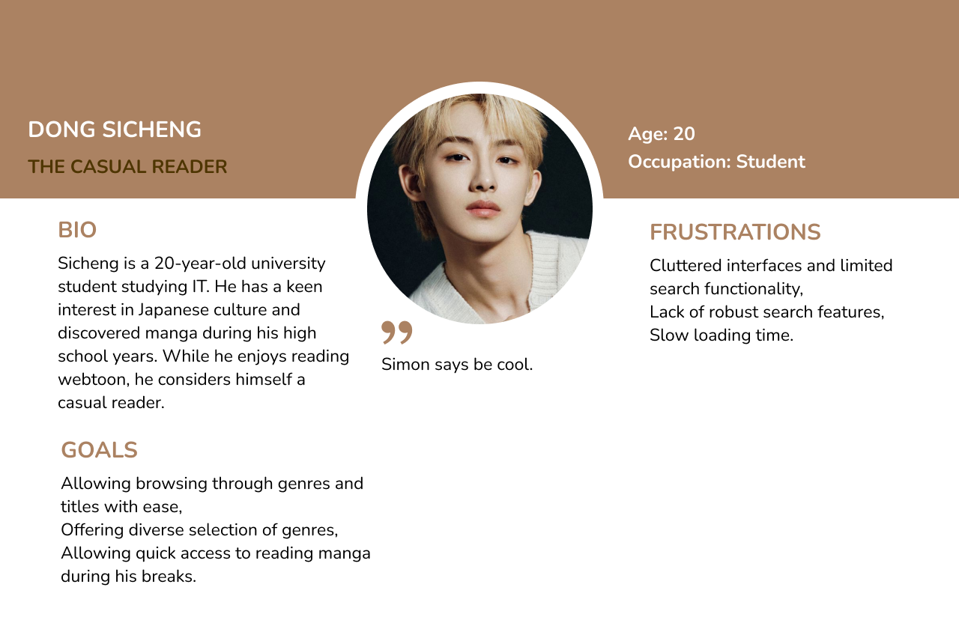

Figure 4User Persona 3

## User Stories

I designed user stories to make assumptions about the features that users could find desirable in an application. These encounters helped ComicZone better understand customer demands and create solutions that meet those needs. 3 distinct user stories were created, and I ranked them from easy to hard in terms of relevancy. The user story of finding and enjoying preferred comics was considered crucial, as the application’s main selling point is to offer a pleasant comic- reading experience. These stories helped me develop and execute a number of features that were tailored to the specific needs of our users, making their experience more customized and engaging.

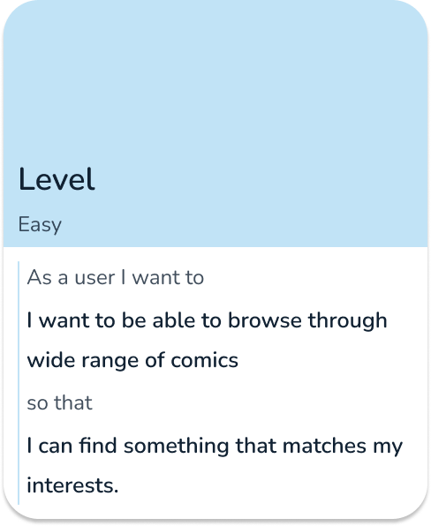

Figure 5 User stories 1

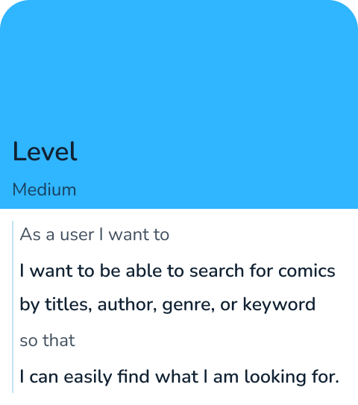

Figure 6 User stories 2

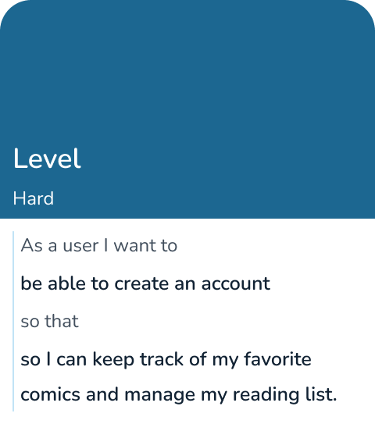

Figure 7 User stories 3

## User flow and Task flow:

Task flows show the steps a user takes to do a particular task, whereas user flows show the sequence of activities a user takes to accomplish a more general goal. Task flows were important, but so were user flows while building ComicZone. They made sure that navigation was easy to use and assisted in mapping out the user path. I could see how users use the application, from finding comics to reading and interacting with the community, by sketching out these flows. The prototype was designed with the help of this approach, which underlined important transitions and interactions and made sure users could easily navigate ComicZone.

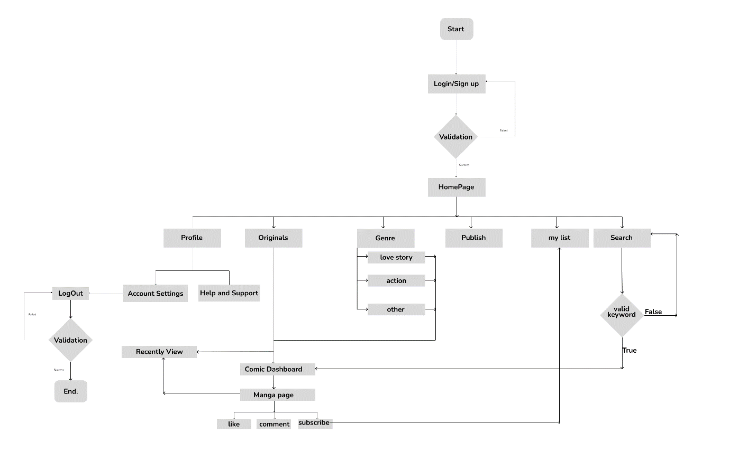

Figure 8 User flow and task flow

## Brainstorm

I gathered ideas and showed the primary features of the application during the brainstorming process, which served as the foundation for the design of ComicZone. I considered a number of factors, including community involvement, user engagement, and content accessibility. Through promoting candid conversation and imaginative thinking, I produced an extensive array of concepts that would serve as the basis for ComicZone. Through cooperation, I was able to figure out the application’s key features, which provided guidance for the rest of the design process.

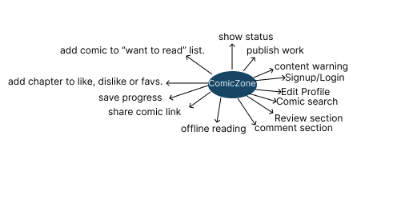

Figure 9 brain storming of ComicZone

## Lo-Fi Wireframes:

Lo-fidelity (Lo-Fi) wireframes were an essential tool in the ComicZone design process for laying out the fundamental organisation and design of the application. These wireframes, which prioritised utility above looks, provide a basic structure. I was able to swiftly iterate on a lot of concepts without being weighed down by specifics by keeping the design abstract and minimal. Using Lo-Fi wireframes, I was able to set up the application’s general flow, map out the user interface, and highlight important elements like content regions and navigation menus. This fundamental stage made sure that ComicZone’s primary features were clear and easy to use from the beginning by laying the framework for the creation of high-fidelity prototypes.

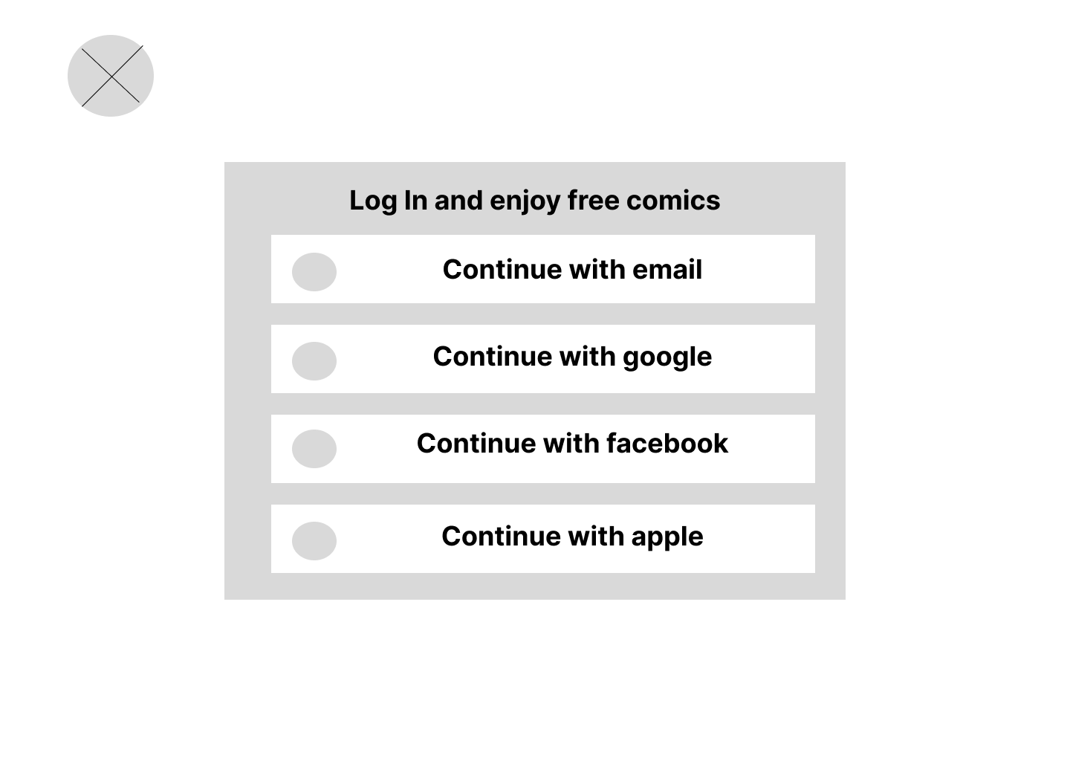

Figure 10 login

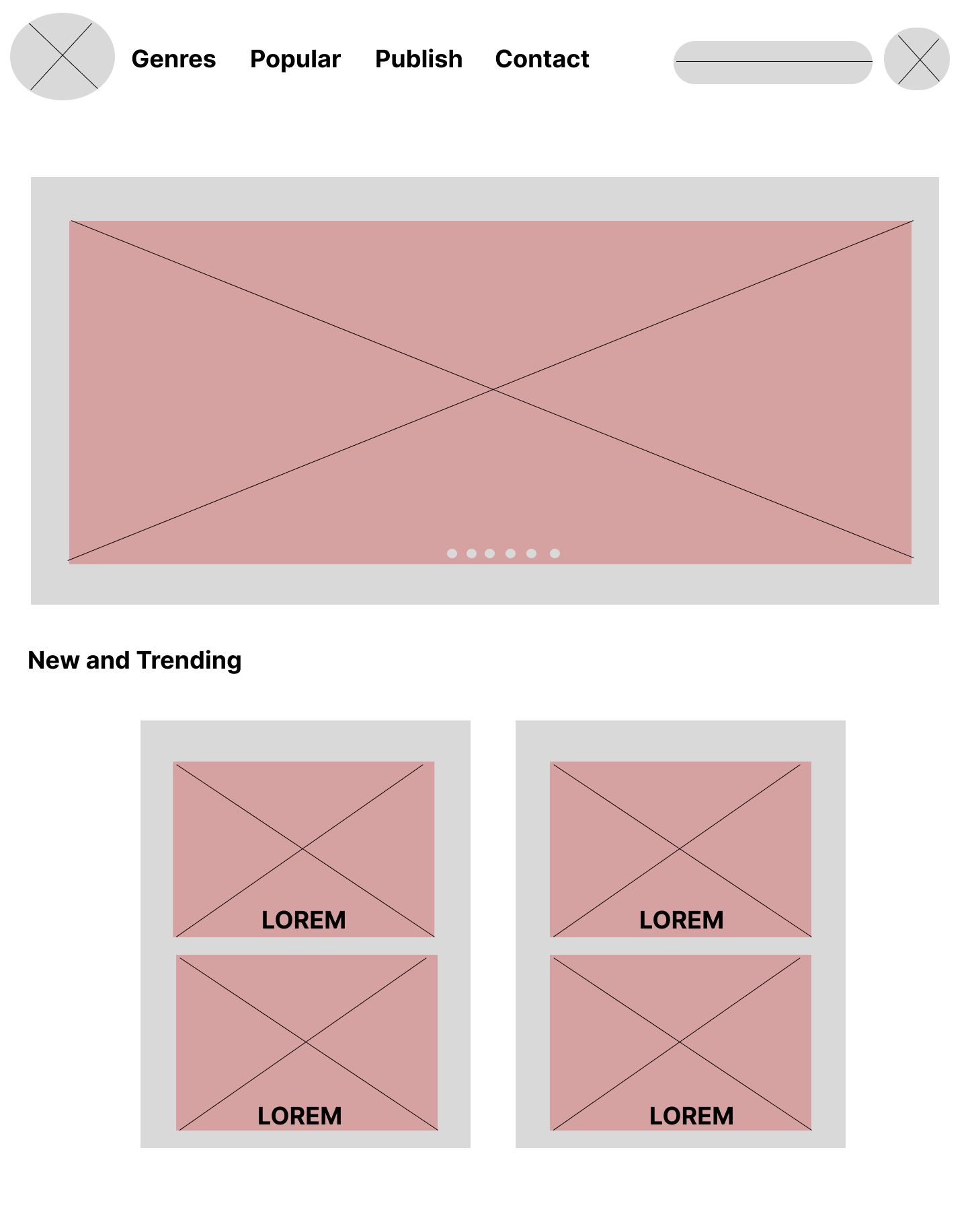

Figure 11 home

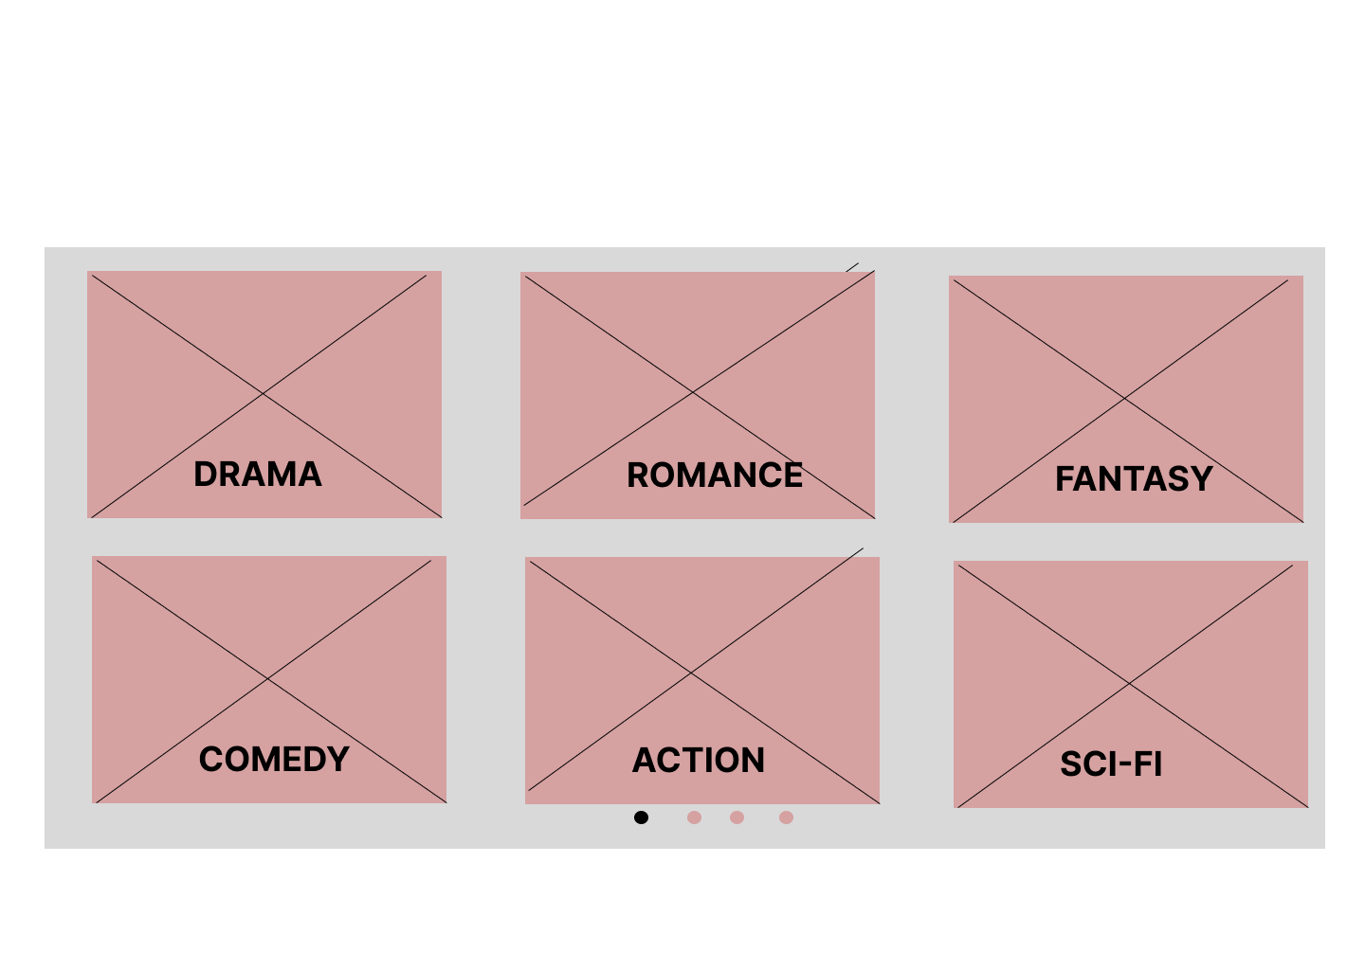

Figure 12 genres

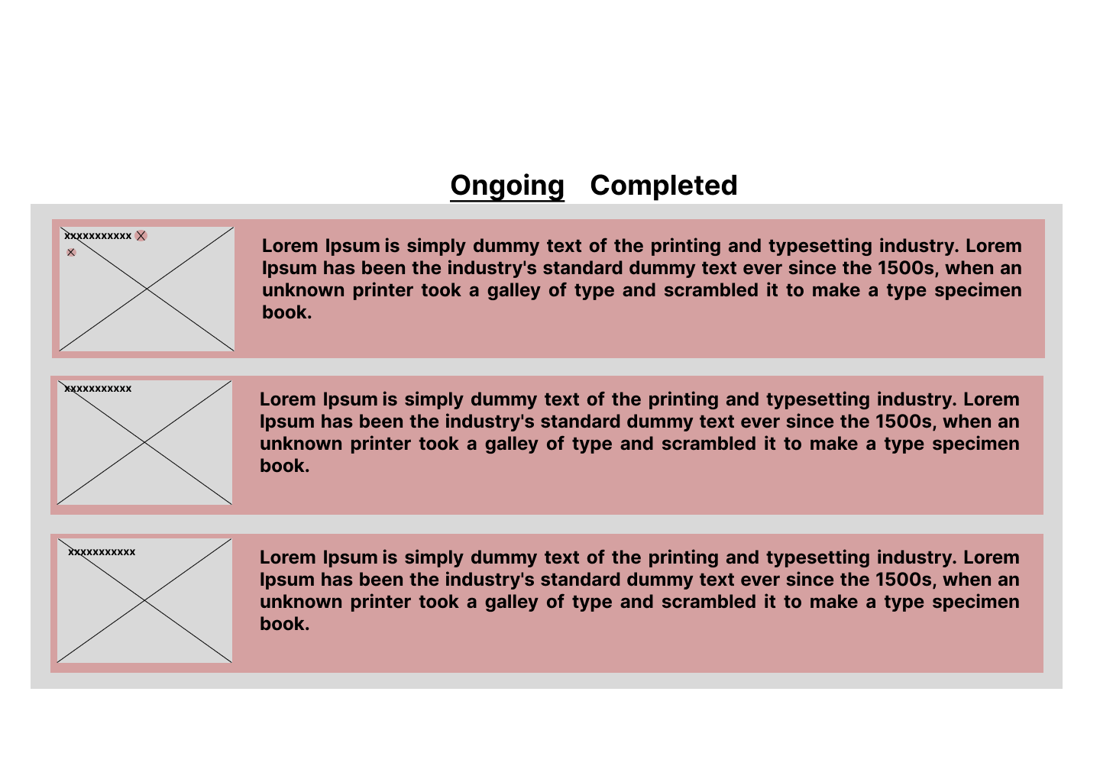

Figure 13 popular

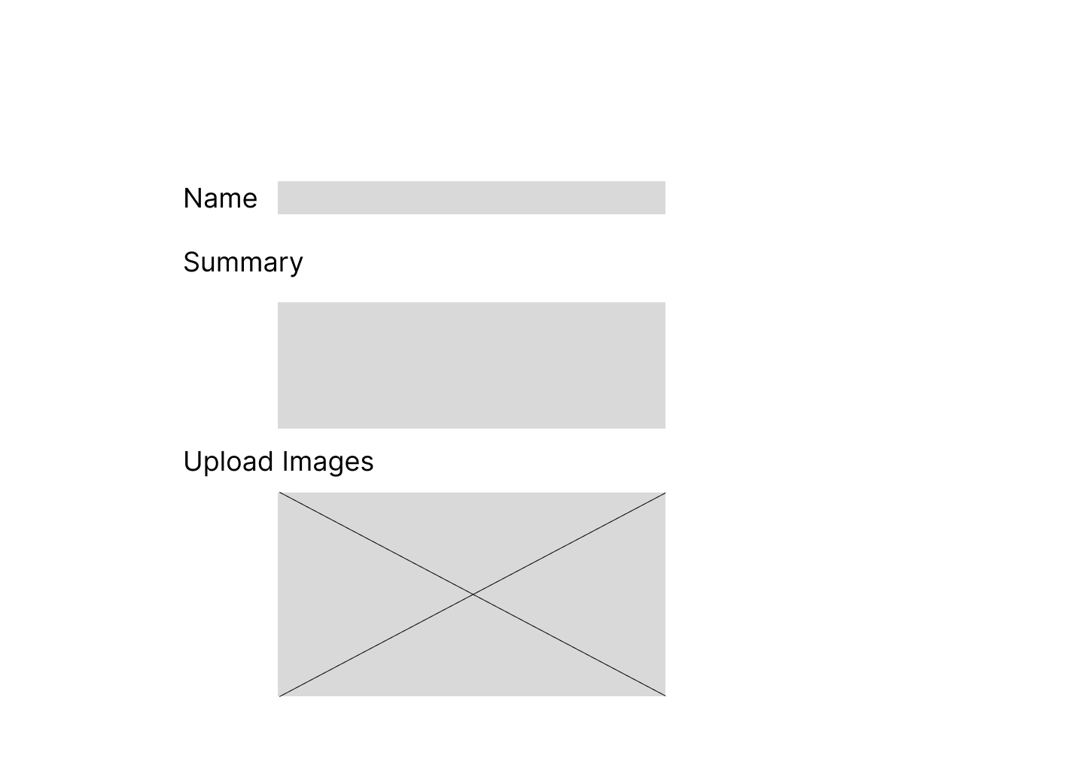

Figure 14 publish

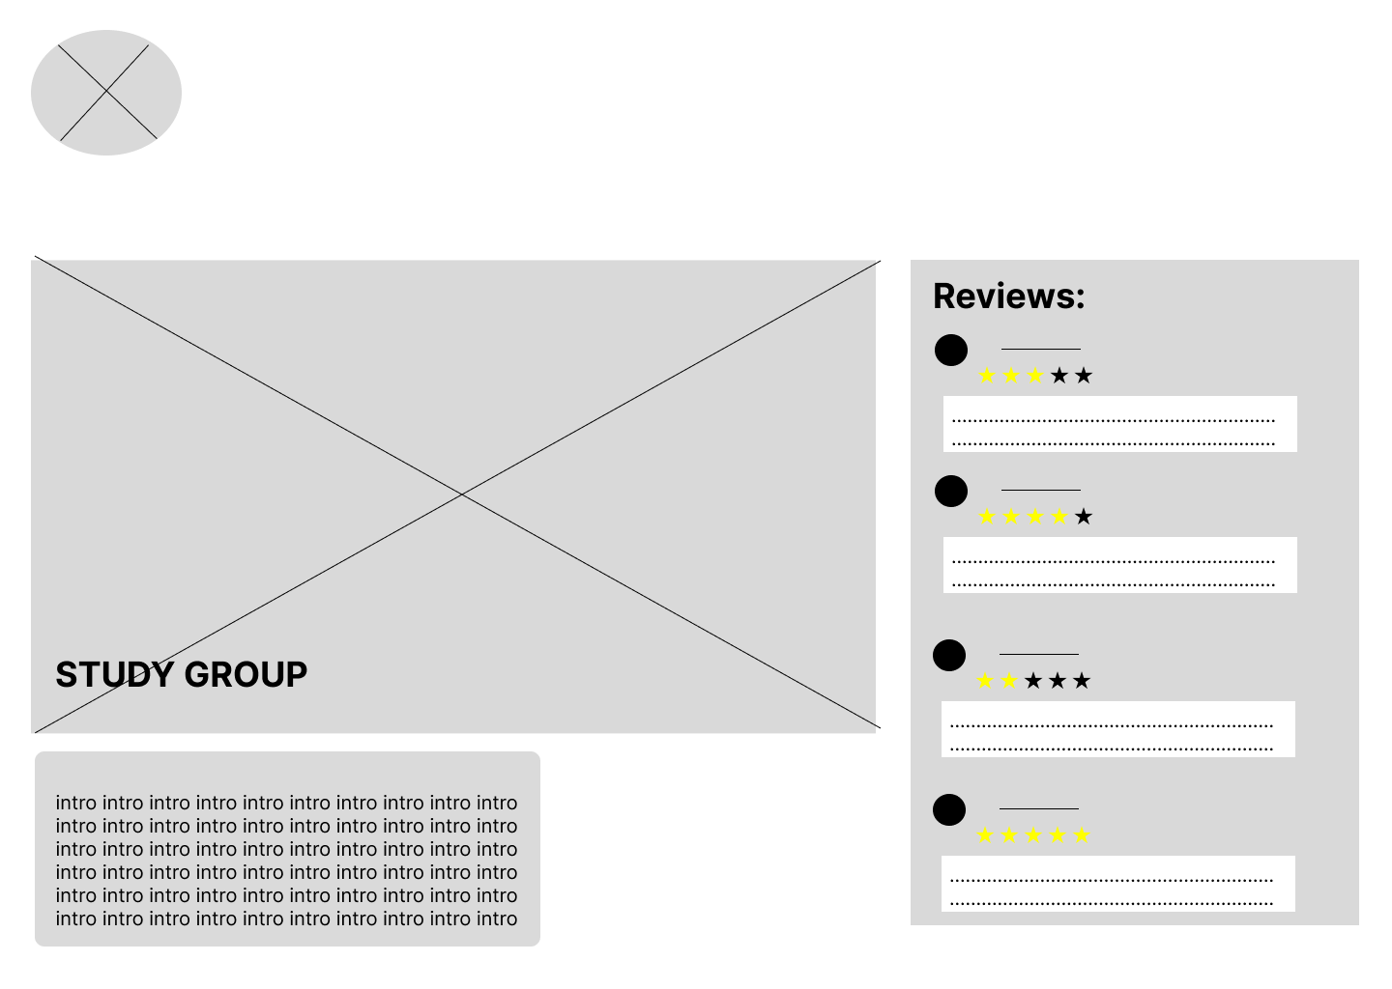

Figure 15 review

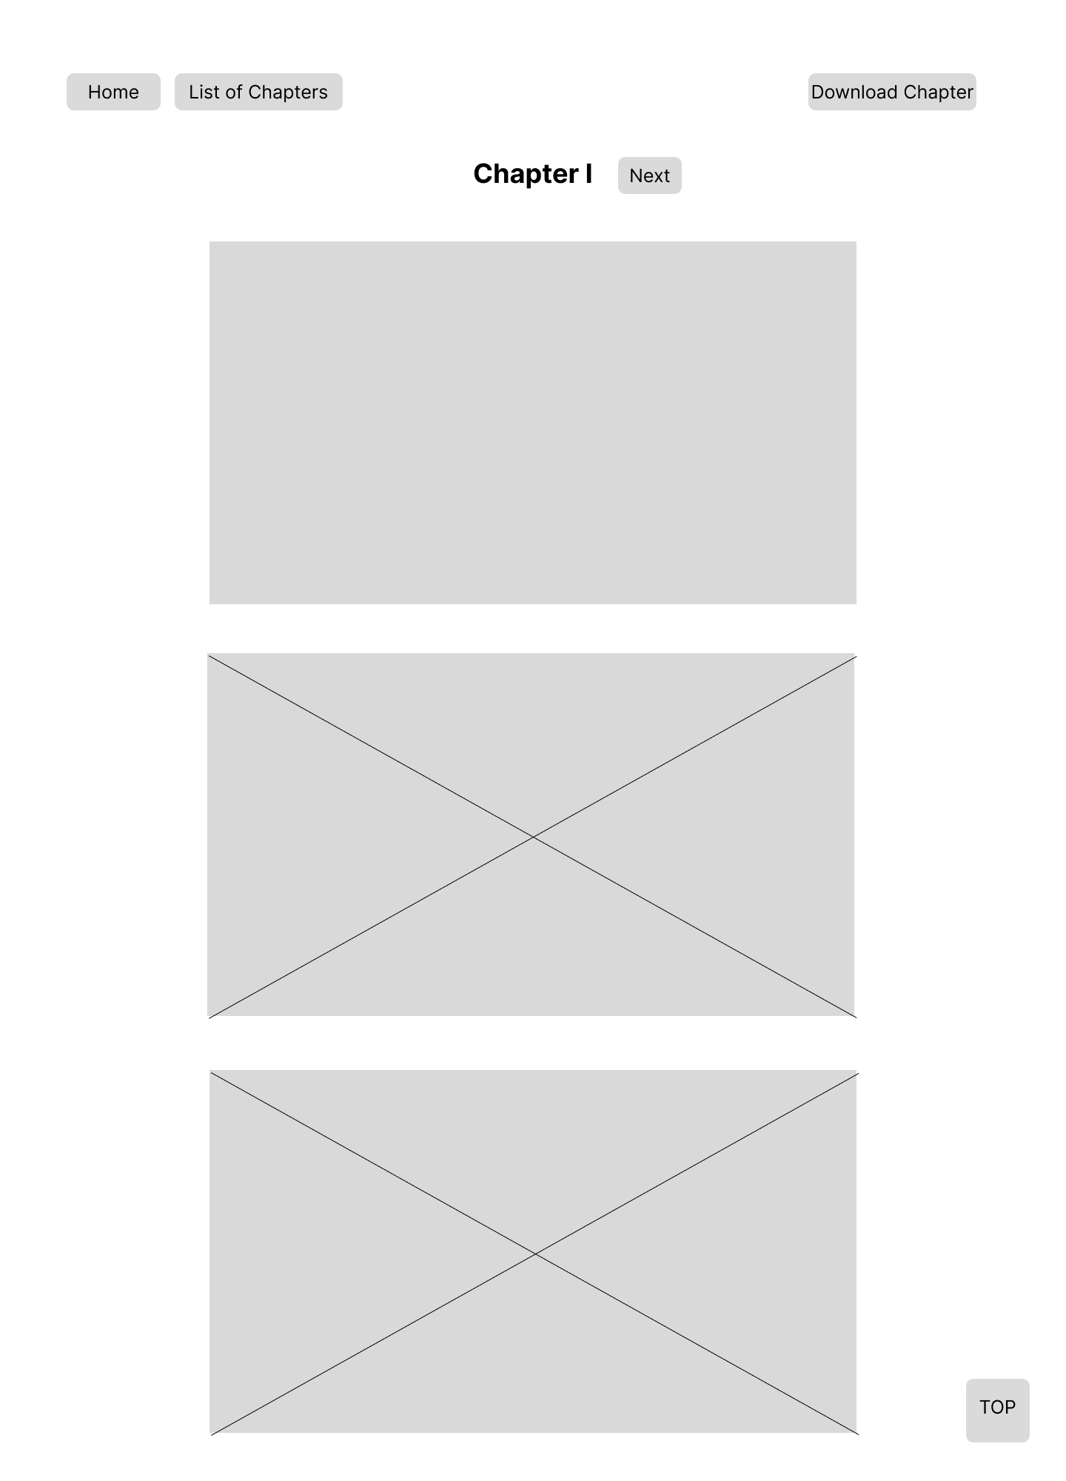

Figure 16 chapter review

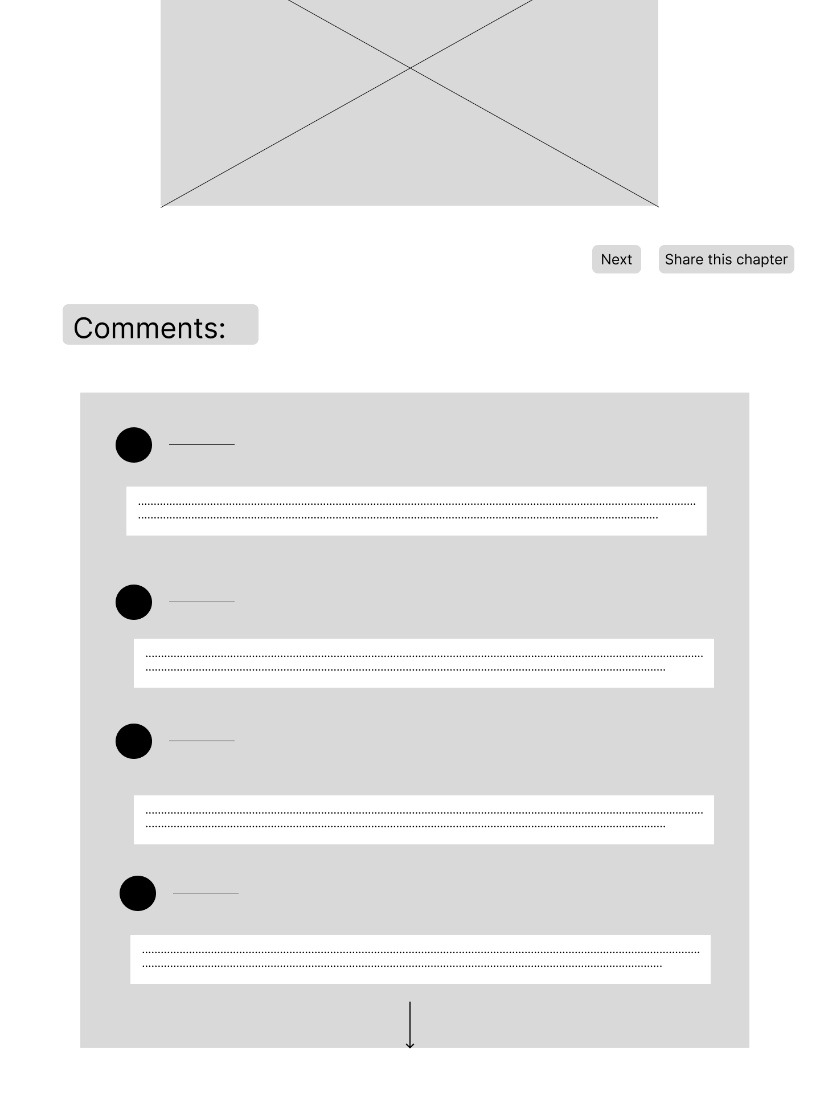

Figure 17 comment

## Wire flow:

The low-fidelity wireframes were connected throughout the wire flow stage to produce an effortless representation of the ComicZone user journey. Individual wireframes were integrating into wire flows to show how users would move between screens, emphasizing the transitions and interactions between various application sections. Using this process, I was able to see the general flow and make sure that the actions- finding a comic, reading, and using community features, for example- went in a logical order. I may spot possible blockages or confusing areas early in the design phase and make the required corrections by charting these linkages. The wire flow offered a precise guide for creating high-fidelity prototypes, guaranteeing a seamless and simple user interface.

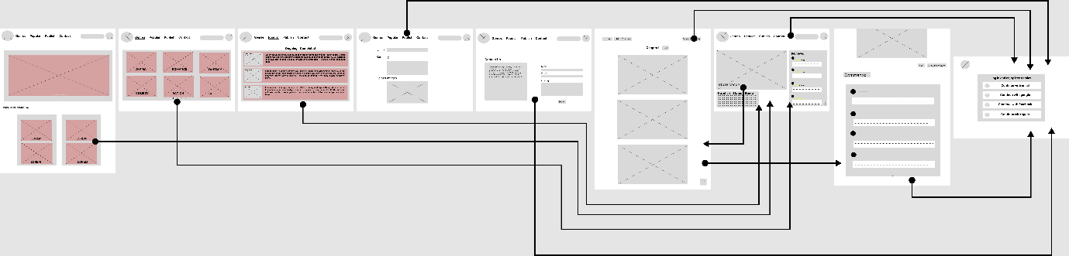

Figure 18 wireflow

## Mood board:

To define the application’s visual style and tone, a mood board for ComicZone was made. The combination of pictures, colour shades, styles, and design components acted as a visual guide to determine the project’s aesthetic approach. The mood board served to communicate the intended appearance and feel of ComicZone by selecting a unified collection of visual references, guaranteeing uniformity throughout the user interface. It used characteristics like strong colours, dynamic layouts, and comical font that mirrored the lively and captivating quality of comics. In order to create a welcoming and engaging experience for comic book fans, the mood board played a crucial role in coordinating the design team’s vision and making sure the visual design connected with the intended audience.

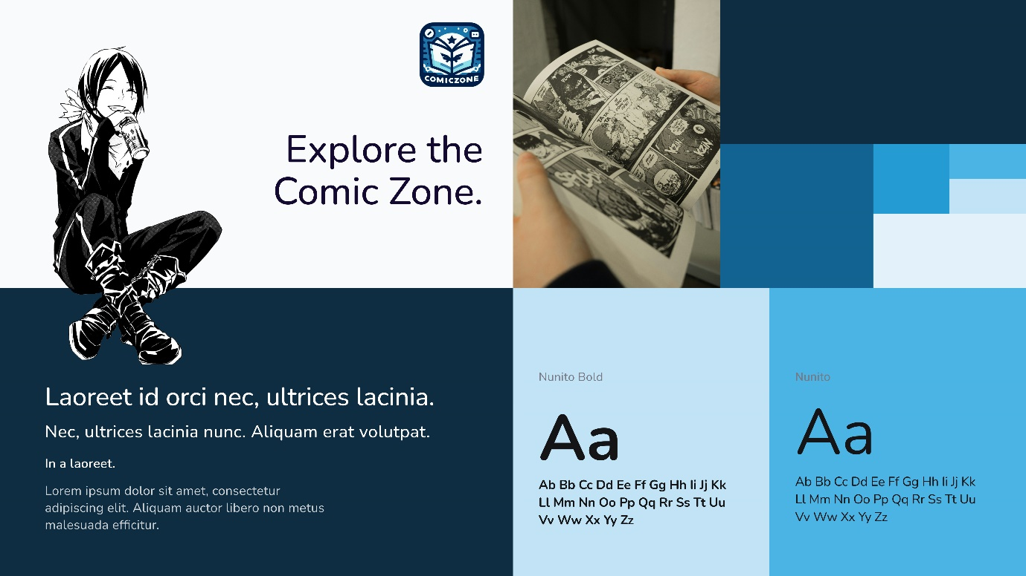

Figure 19 mood board of ComicZone

# Evaluation and Testing

## Evaluation methodologies:

* Schneiderman’s 8 Golden Rules.
* Nielsen’s Heuristics

I used accessibility testing, heuristic evaluation, and usability testing together to assess ComicZone. Real users from our target market interacted with the prototype to carry out predetermined activities during usability testing. This approach gave clear insights into the problems and experiences of users. Design specialists carried out heuristic review, comparing the interface to Schneiderman’s guidelines and Nielsen’s heuristics to find any discrepancies in the design or any problems.

## Usability and Accessibility.

### 3.2.1 Strive for consistency || Consistency and Standards.

* **Schneiderman’s 8 Golden Rules:** Strive for consistency.
* **Nielsen’s Heuristics:** Consistency and Standards.

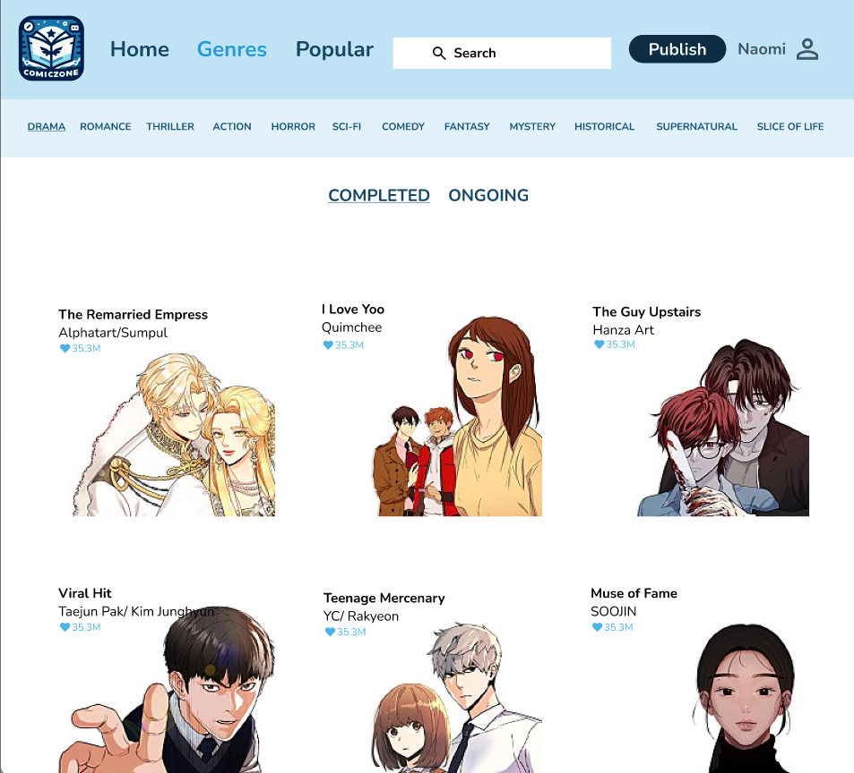

Figure 20 rule 1

ComicZone follows a design style that is consistent with the idea of “striving for consistency/ consistency and standards.” Due to the clean design language used by the interfaces, visitors to the websites will recognize features and layouts.

### Enable frequent users to use shortcuts || Flexibility and efficiency of use.

* **Schneiderman’s 8 Golden Rules:** Enable frequent users to use shortcuts.
* **Nielsen’s Heuristics:** Flexibility and efficiency of use.

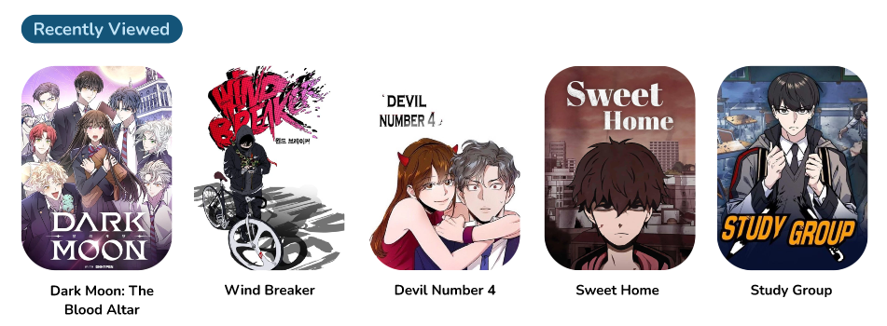

Figure 21 rule 2

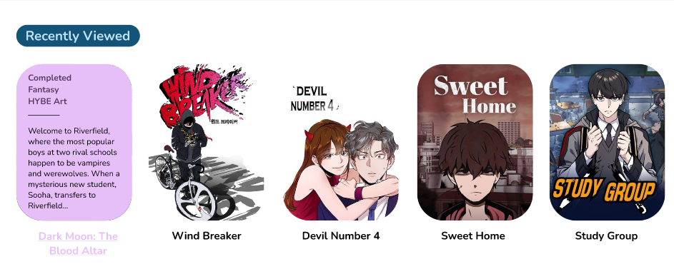

Figure 22 rule 2

Regarding the concept of “enable frequent users to use shortcuts/Flexibility and efficiency to use,” ComicZone offers the status, genre, creator’s name and storyline trailer in the front of the comic while hovering around.

### Offer Informative Feedback || Design dialogue to yield closure || Visibility of system Status.

* **Schneiderman’s 8 Golden Rules:** Offer Informative Feedback || Design dialogue to yield closure.
* **Nielsen’s Heuristics:** Visibility of system Status.

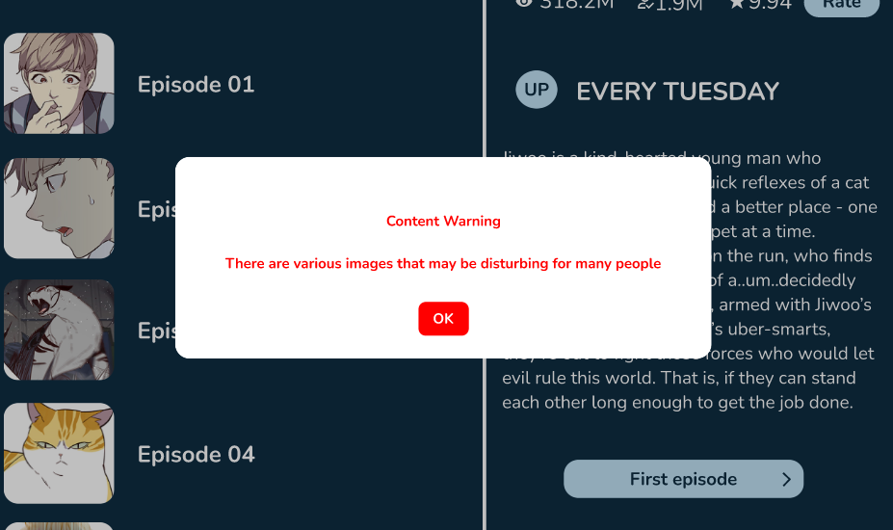

Figure 23 rule 3

ComicZone gives a ‘content warning’ popup before one is led to the specific chapter of a comic which is full of explicit story lines. This prevents the user from triggering personal issues. This functionality aligns with the ideas of providing pertinent information and supporting system state visibility, all of which improve comprehension and the user experience on both platforms.

### Reduce short-term memory load || Recognition rather than recall.

* **Schneiderman’s 8 Golden Rules:** Reduce short-term memory load.
* **Nielsen’s Heuristics:** Recognition rather than recall.

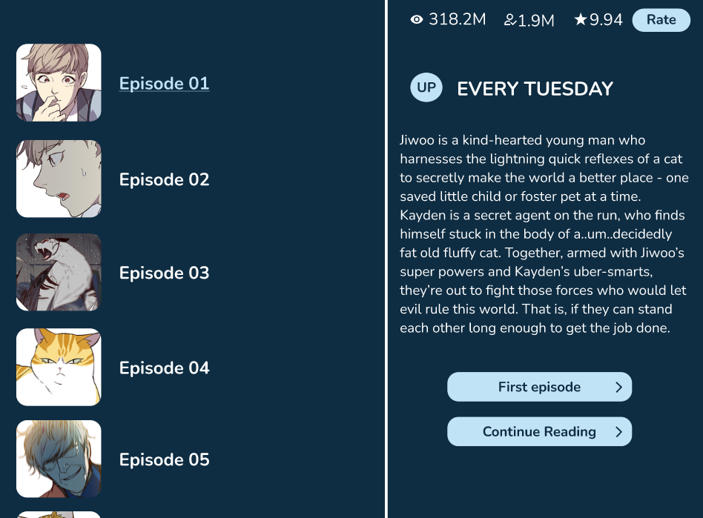

Figure 24 rule 4

The “Continue Reading >” button appears beside the list of chapters when a reader clicks on a specific comic or manga in ComicZone. This button makes it obvious that they can continue reading without having to remember the chapters they have already read, which helps readers with short-term memory stress.

### Support internal locus of control || Permit easy reversal of action || User control and freedom.

* **Schneiderman’s 8 Golden Rules:** Support internal locus of control || Permit easy reversal of action.
* **Nielsen’s Heuristics:** User control and freedom.

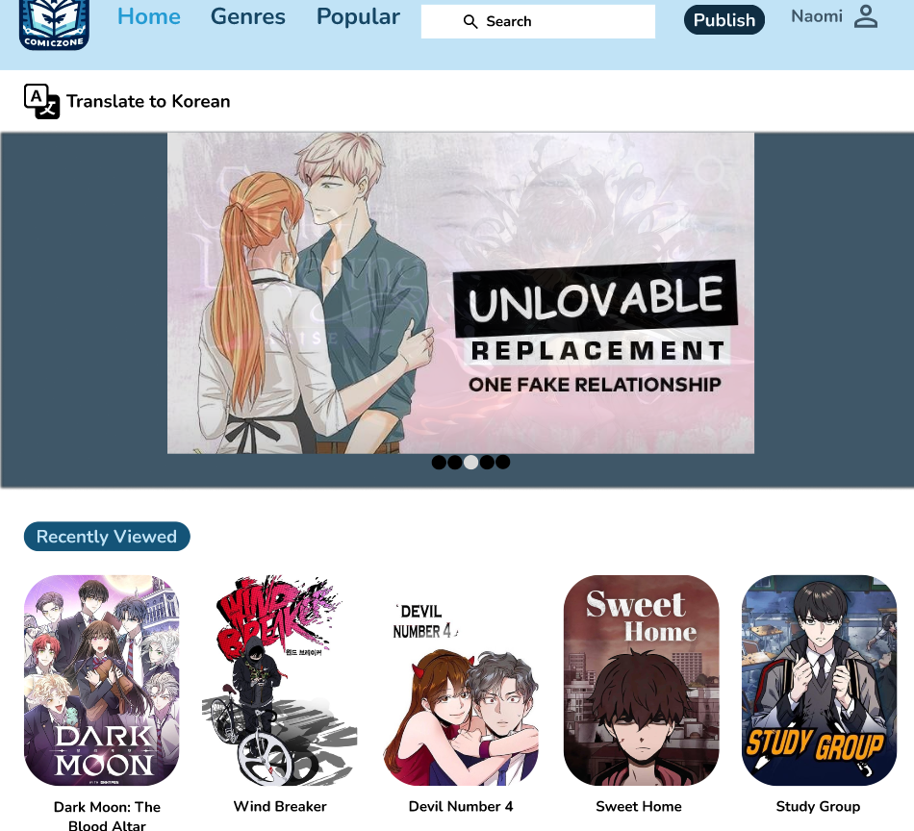

Figure 25 rule 5

Users may quickly browse a list of recently seen comics via ComicZone’s “Recently Viewed” section in the Home page, which encourages them to maintain control over their reading history.

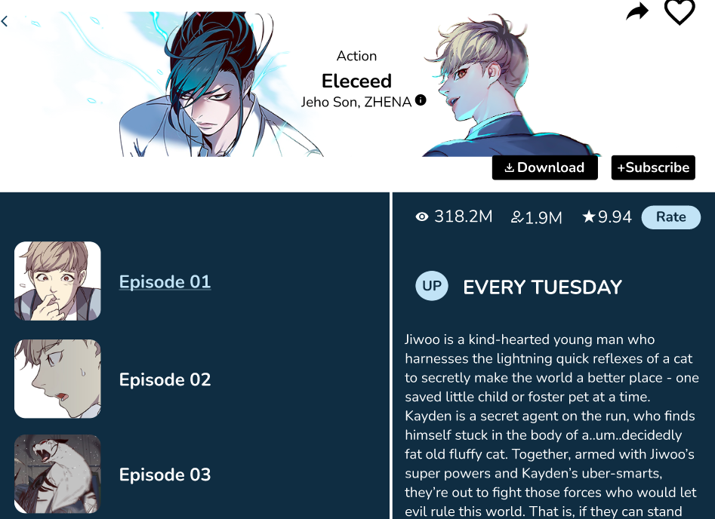

Figure 26 rule 5

Read chapters are marked light blue and underlined, which facilitates progress monitoring and encourages user independence.

### Offer simple error handling || Help users recognize, diagnose, and recover from errors.

* **Schneiderman’s 8 Golden Rules:** Offer simple error handling.
* **Nielsen’s Heuristics:** Help users recognize, diagnose, and recover from errors.



Figure 27 rule 6

Effective error handling is included in ComicZone’s login screen to guarantee an easy sign-in procedure. Users are prompted with an error message if any forms are missing, asking them to “enter the valid email” and “enter the 8 digit AlphaNumeric.” Usability is improved since users may immediately adjust their input thanks to this instant feedback. The screenshot highlights ComicZone’s user-friendly design while illuminating these problem notifications.

### Error Prevention (Nielsen’s Heuristics)

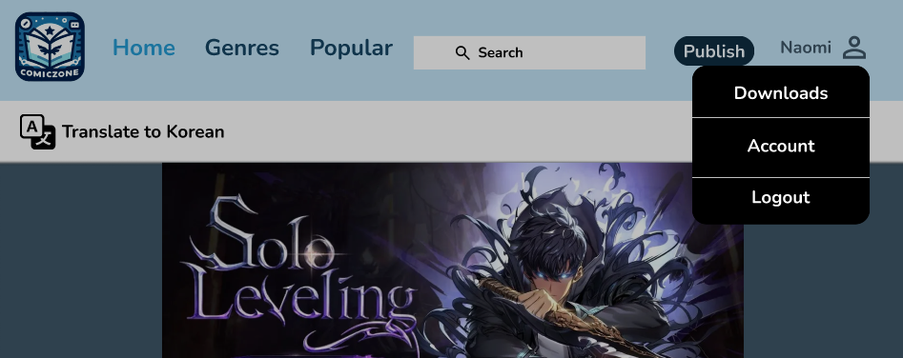

Figure 28 rule 7



Figure 29 rule 7

ComicZone provides security against unintentional touches and activities. Here, for example, the programme displays a confirmation message in the event that the user presses the log out button.

### Aesthetic and minimalist design (Nielsen’s Heuristics)



Figure 30 rule 8

ComicZone’s comics have a simple, minimalist appearance since changes are shown by little grey symbols. This little visual hint efficiently alerts users to new updates without overflowing the user experience and appeal by using these minimalist design principles, which also improve visual clarity and simplicity of the user interface.

### Match Between System and Real World (Nielsen’s Heuristics)



Figure 31 rule 9

ComicZone conforms to real-world standards by using recognisable iconography, such as a person for the user account and a magnifying glass for searching comics. Because of these widely used symbols, navigating is simple and intuitive. These symbols are included in the picture to highlight how ComicZone improves usability by reflecting user’s actual experiences.

### Help and Documentation



Figure 32 rule 10

## Usability and Accessibility Issues uncovered.

### 3.3.1 Usability Issue:



Figure 33 rule 10 issue

I discovered during prototype testing that the home page’s “privacy” implementation lacked adequate description. The heuristic rule “Help and Documentation” was broken by this. The changes I made afterwards are in the Revamped design section:

### 3.3.2 Accessibility Issue:

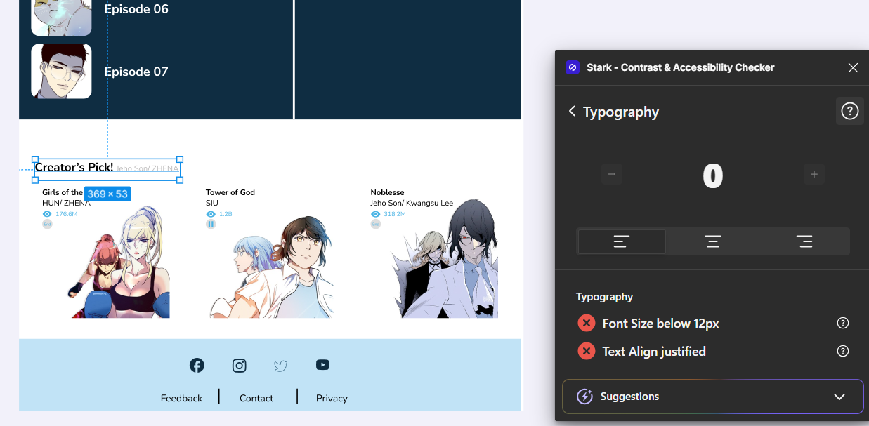

Figure 34 accessibility issue

I tested the typefaces for accessibility using a typography plugin while evaluating ComicZone. Certain fonts were too tiny to read comfortably, according to the plugin. Readability may be hampered by several problems, especially for users who are visually impaired. These problematic typefaces are shown in the screenshot, emphasising the need for changes to guarantee that all text is readable and clear. ComicZone can give all readers a better reading experience by fixing these font problems.

The improvised design is in the Revamped design section:

## List of question for User testing:

I separated the survey into three areas on the Google Form:

* Personal Questions
* Questions related to “Schneiderman’s Eight Golden Rule and 10 Heuristics.”
* Accessibility Questions.

### 3.4.1 Personal Questions:

In this section, only the Email, Full name, Age, Occupation of the user using the ComicZone app was asked along with one specific question wanting to know how often do the user enjoy reading comics.

### Questions related to Schneiderman’s 8 Golden rules and Nielsen’s Heuristics:

This section usually have the questions related to the usability that the application has. This section in the form has total 17 questions which are listed below:

1. Can you tell whether the app has loaded and if there are any errors?
2. Do the buttons and controls in the UI utilize the same language and symbols?
3. Can you fast undo actions when reading a comic?
4. Do similar components react consistently across several comics?
5. Can you find and use features without knowing where they are?
6. Is there a warning before you read chapters?
7. Does the application look clean and simple, or is it too crowded?
8. Is the interface disorganized and you cannot easily focus on the comic content?
9. Are error messages easy to understand and give a solution?
10. Are you able to read the chapters without unnecessary steps or distractions?
11. Are you able to make the comic bigger and smaller as needed?
12. Are you able to keep track of how far you have read the comic?
13. Can you mark the comic you like to favorites?
14. Are you able to search for the comics you want to read?
15. Can you share the comics you like to your friends?
16. Can you subscribe and download the comic you are reading or want to read?
17. Do you get recommendations for additional comics you might enjoy?

### Questions related to the Accessibility.

This section in the form includes total 3 questions only. The questions are related to the accessibility that has been used in the ComicZone application. The 3 questions are:

1. Can you fast switch between languages for the text on the app?
2. Is it easy for the design’s text to be read aloud by voice?
3. Can you quickly find and activate the language translation and voice reading features in the form?

## User Testing and Testing Analysis:

### 3.5.1 Reviews of Users on testing:

Link to the Figma Design: [ComicZone](https://www.figma.com/design/6LL7HHVvQehjfmhSArojVY/CZ?node-id=5867%3A346&t=BHv5rWzIahM0j6x4-1)

For the testing of my application, I picked 3 of my friends. They were:

1. Jeevan Tamang: [np03cs4a220026@heraldcollege.edu.np](mailto:np03cs4a220026@heraldcollege.edu.np)
2. Sujan Shrestha: [sujanstha.0122@gmail.com](mailto:sujanstha.0122@gmail.com)
3. Tarang Regmi: [np03cs4a220438@heraldcollege.edu.np](mailto:np03cs4a220438@heraldcollege.edu.np)

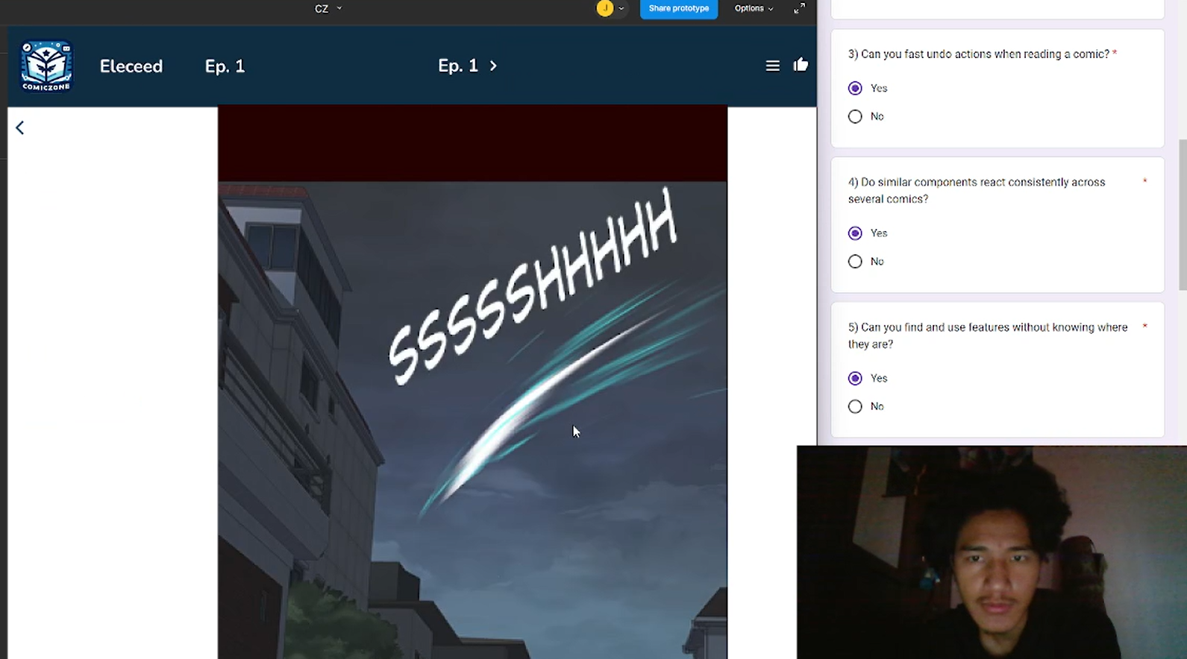

Figure 35 testing 1

Jeevan testing video link: [ComicZone Testing](https://drive.google.com/file/d/1vaSac5TLTQtp4JLAxt8o7m4ZsaQ4S7V3/view?usp=drive_link)

While testing, Jeevan, who was the first reviewer pointed out that he could not make the comic either smaller or bigger while reading it.

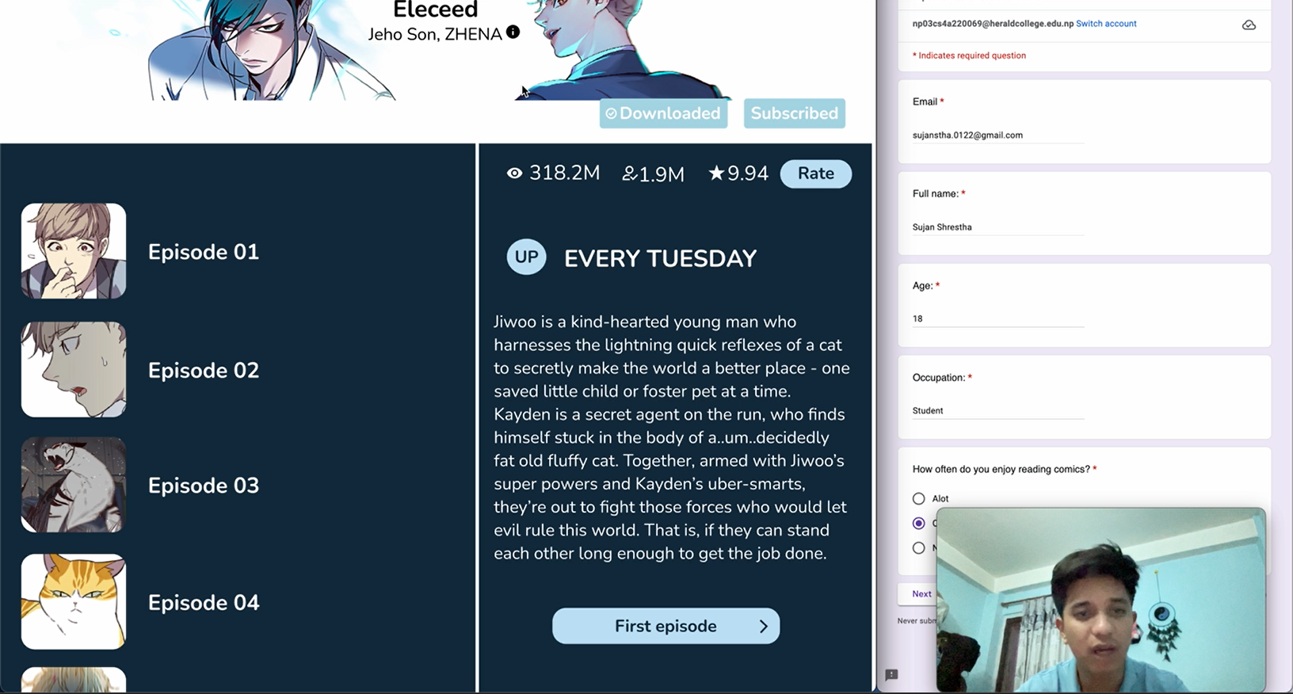

Figure 36 testing 2

Sujan testing video link: [ComicZone Testing](https://drive.google.com/file/d/1LX0ZJwBG0HqH7ZOqYOKilCbqliP3jUzZ/view?usp=drive_link)

While Sujan, the second reviewer was testing the app, he pointed out that the fonts were smaller than it needed to be.

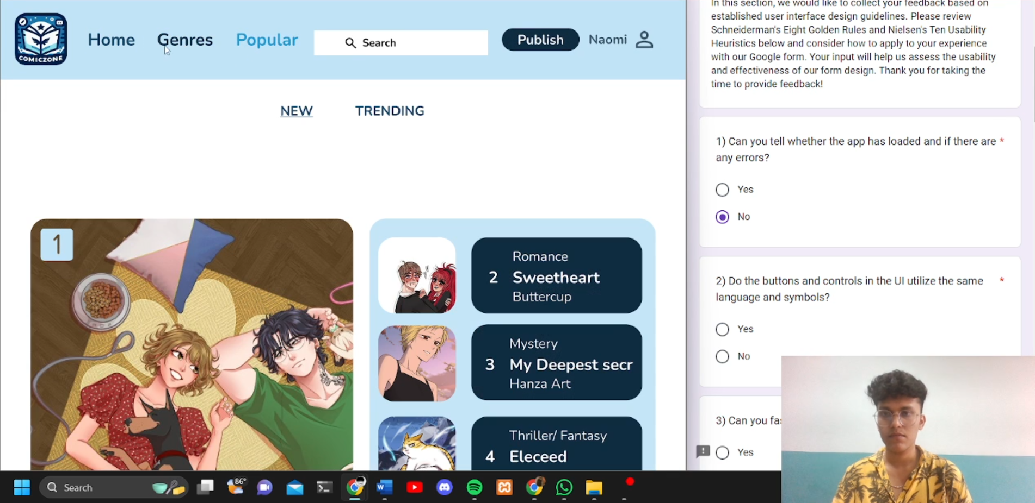

Figure 37 testing 3

Tarang testing video link: [ComicZone Testing](https://drive.google.com/file/d/1UrzBc40TlRbQSKhZfci3EPedgKFS_BN2/view?usp=drive_link)

The last reviewer, Tarang, he pointed out the same problem as the reviewer Sujan.

The problems pointed out by the viewers; they are addressed in the Revamp section: Revamp Design.

## Revamp Design

### 3.6.1 Documentation for Privacy in Home page:



Figure 38 rule 10 issue revamp

This helps prevent the violation of the Heuristic rule: Help and Documentation and makes it easier for user experience.

### Change in Font size using typography plugin:

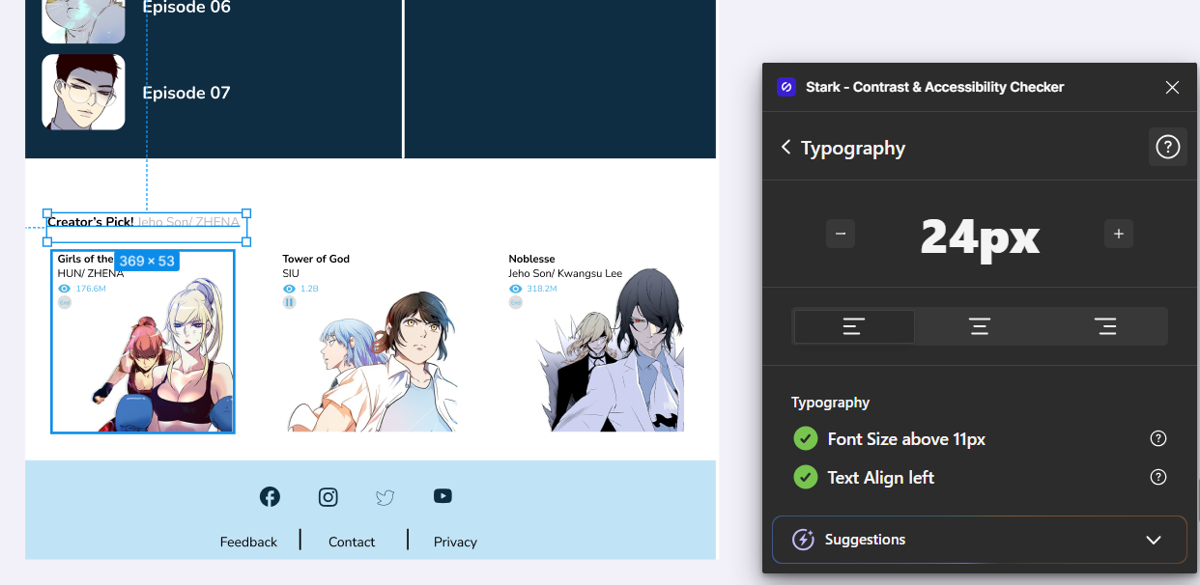

Figure 39 font size revamp

With the help of this plugin, I could change the font to its proper size which helps the user to read the content in the application.

# Conclusion

Creating an intuitive and easily navigable platform for manga, manhwa, and comic book enthusiasts has been the aim of ComicZone’s creation. Though comprehensive usability and accessibility testing, we identified and fixed several critical issues, such as improving navigation, preventing errors, and ensuring readable fonts. Classmate feedback produced enlightening remarks that led to significant improvements in the design.

Through continual refinement, we have made sure ComicZone both meets and beyond user expectations. The finished design demonstrates our dedication to the highest standards of usability and accessibility while providing a simple and engaging user experience. At this point, ComicZone is prepared to be a leading option for comic book readers.

# Appendix

## Screenshot of Questionnaires:

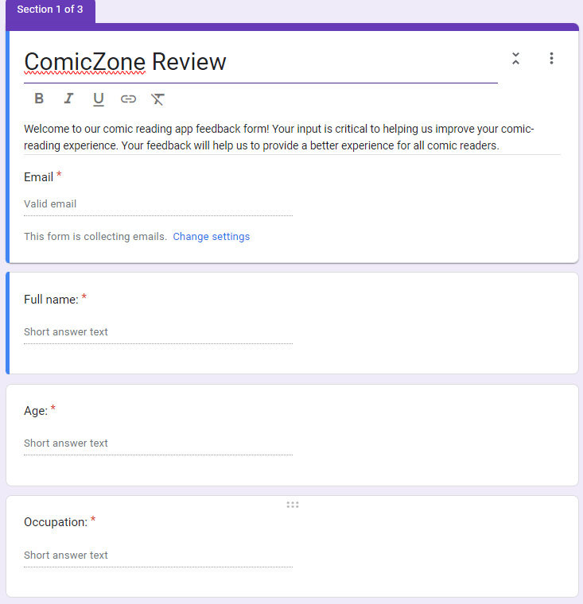

Figure 40 section 1

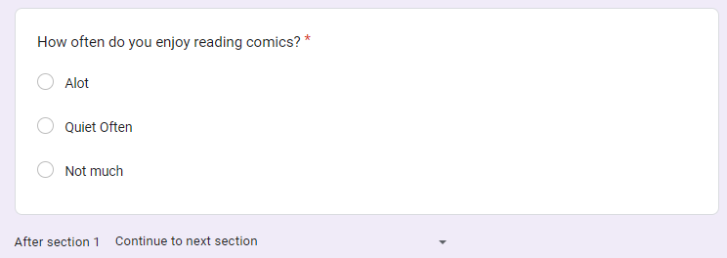

Figure 41 section 1

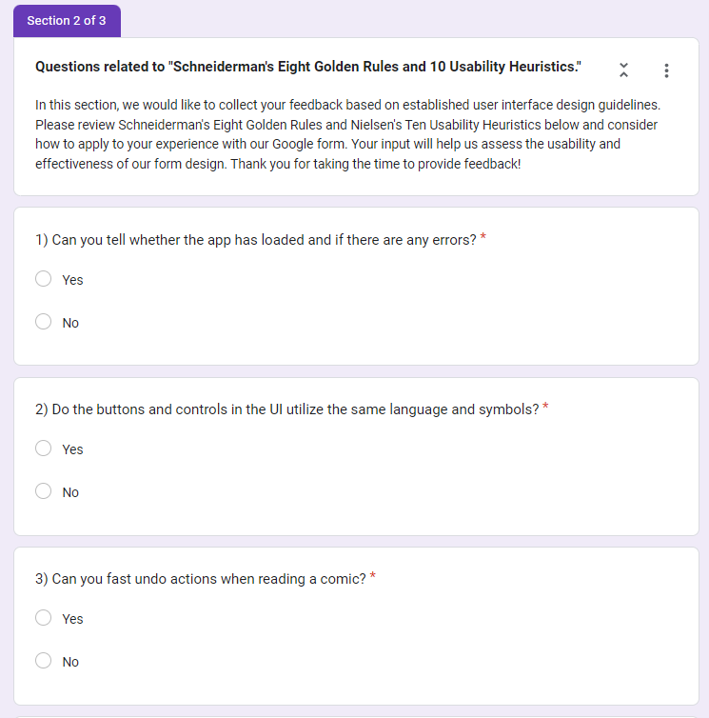

Figure 42 section 2

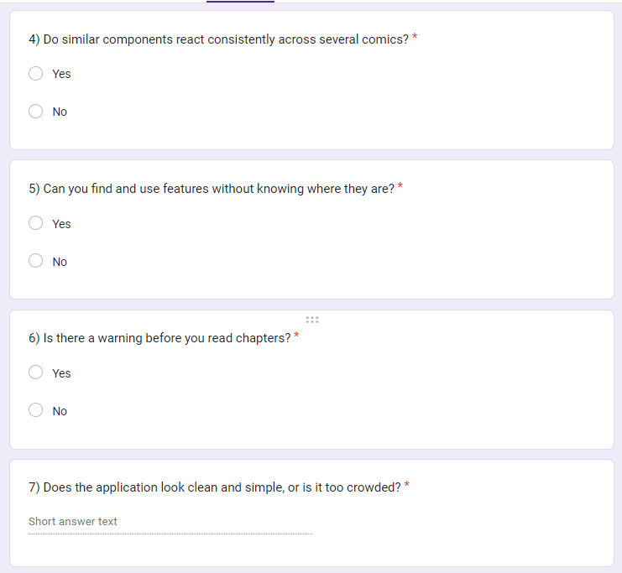

Figure 43section 2 contd.

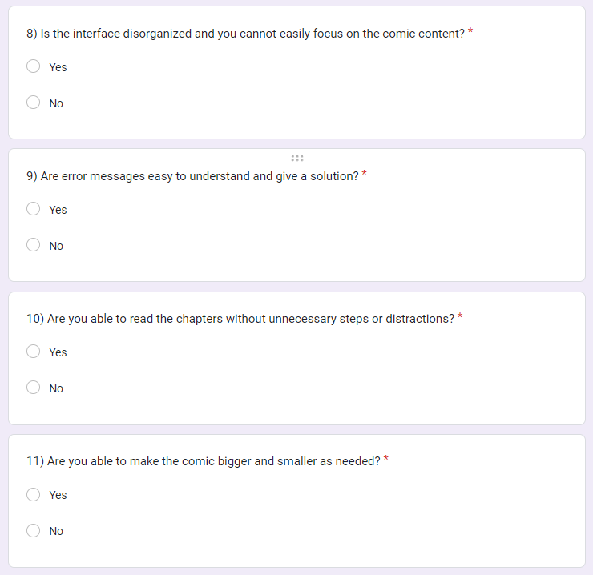

Figure 44 section 2 contd..

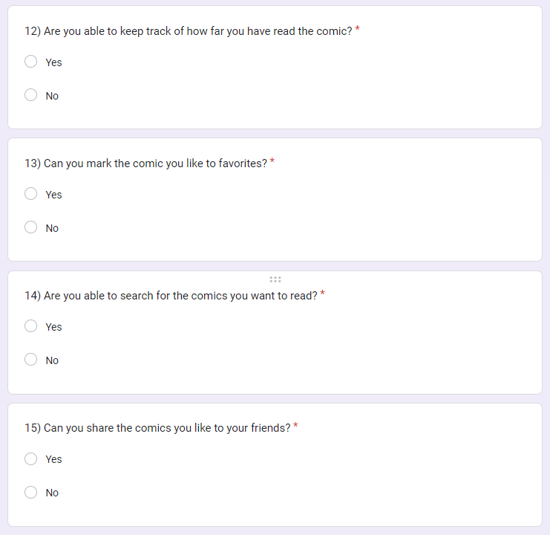

Figure 45 section 2 contd...

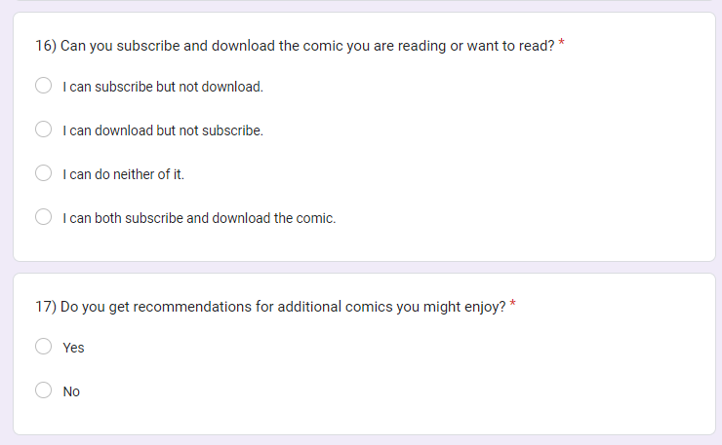

Figure 46 section 2 contd....

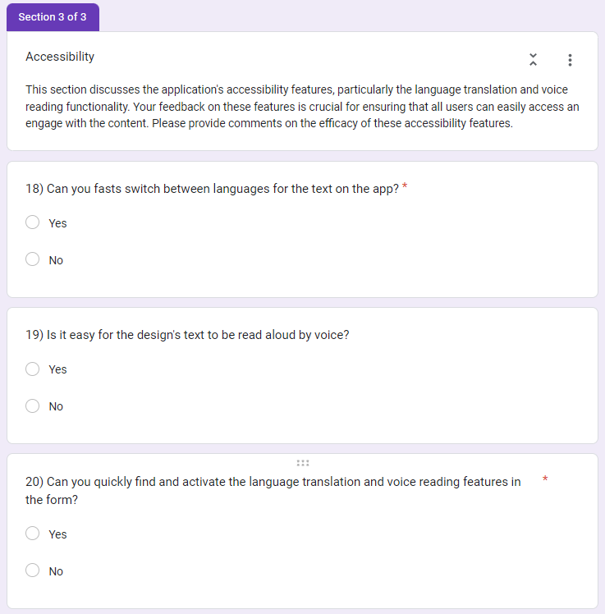

Figure 47 section 3

## Screenshots of Design of ComicZone:



Figure 48 first page



Figure 49 page with logo of app



Figure 50 complete logo page



Figure 51 login



Figure 52 error handling

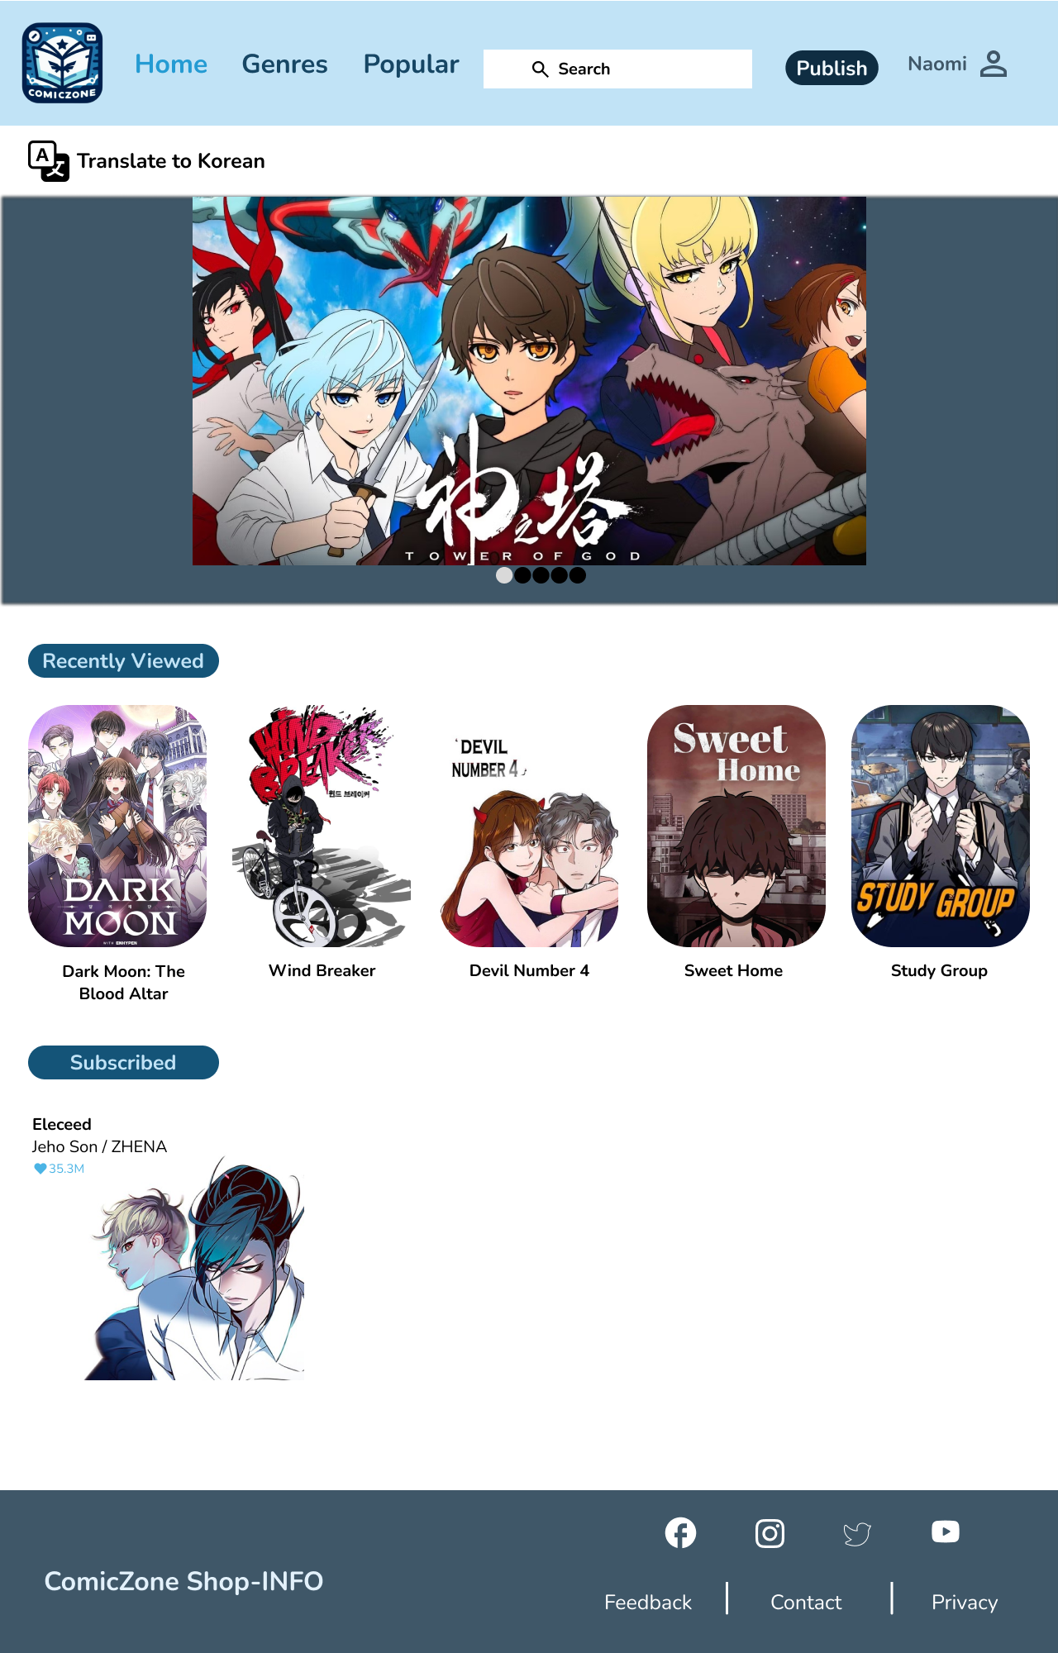

Figure 53 home page

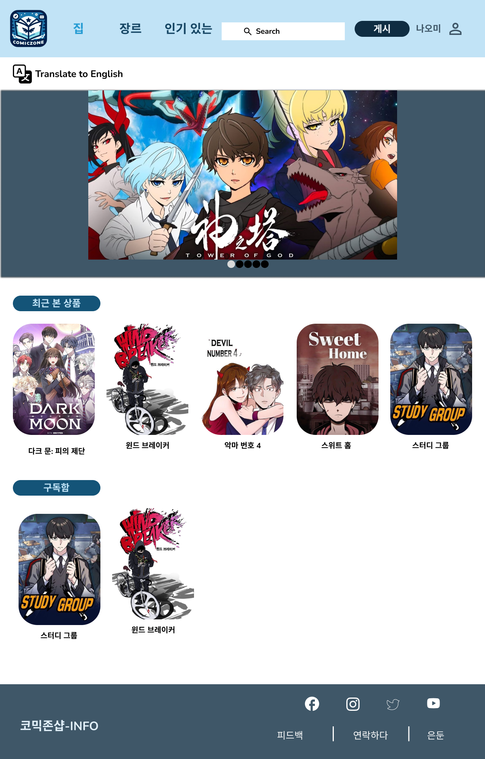

Figure 54 korean home page



Figure 55 privacy documentation

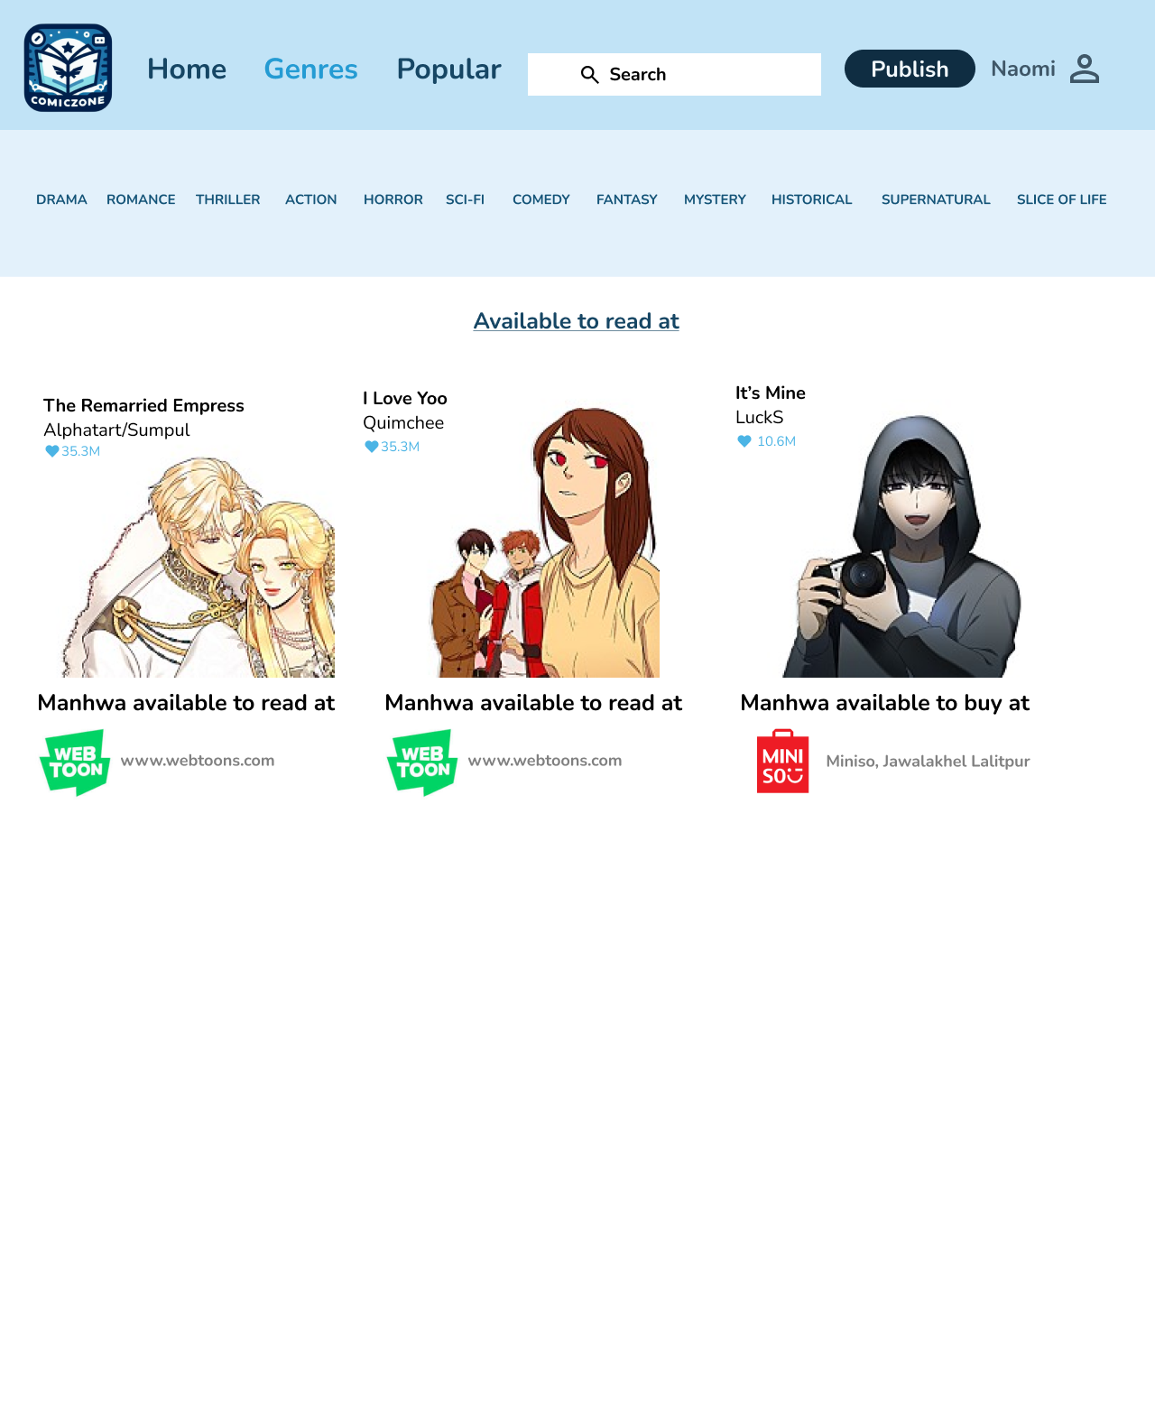

Figure 56 shop page

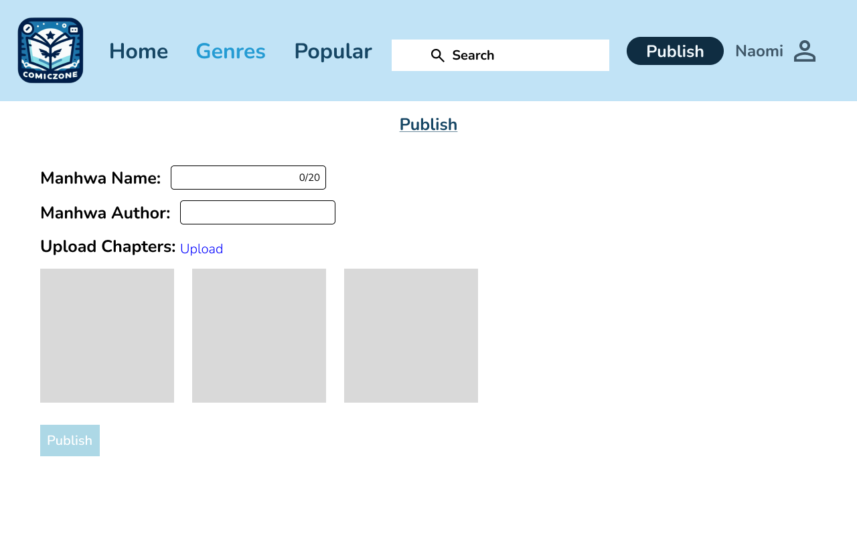

Figure 57 publish



Figure 58 genres complete

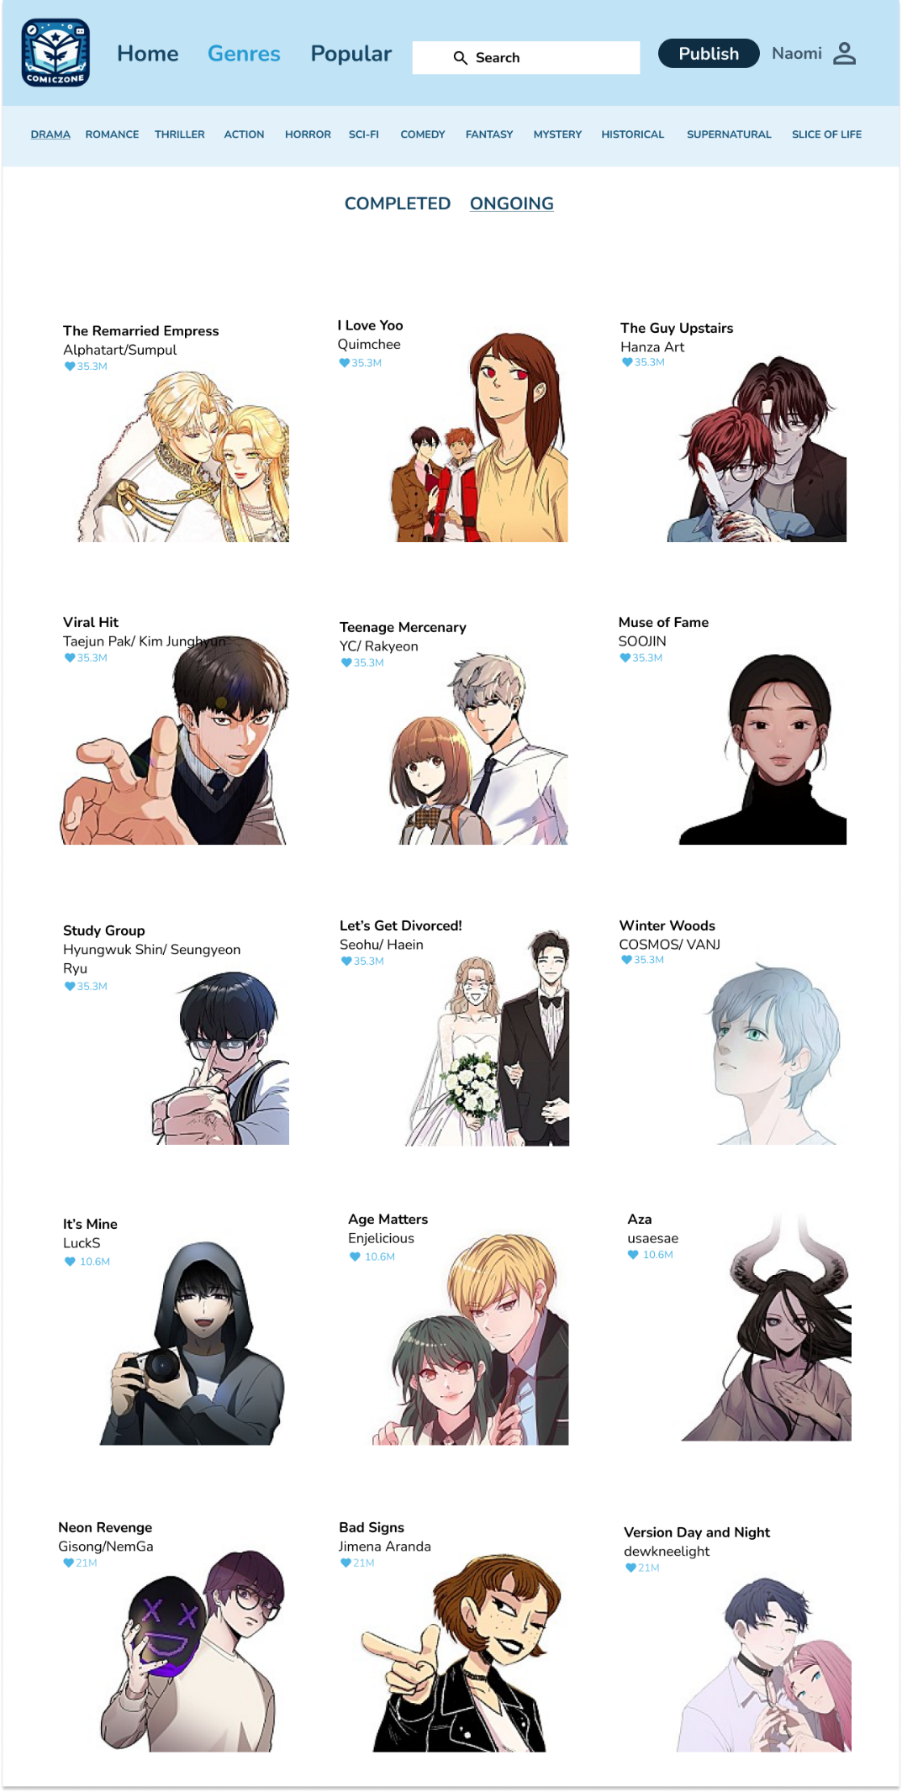

Figure 59 genres ongoing

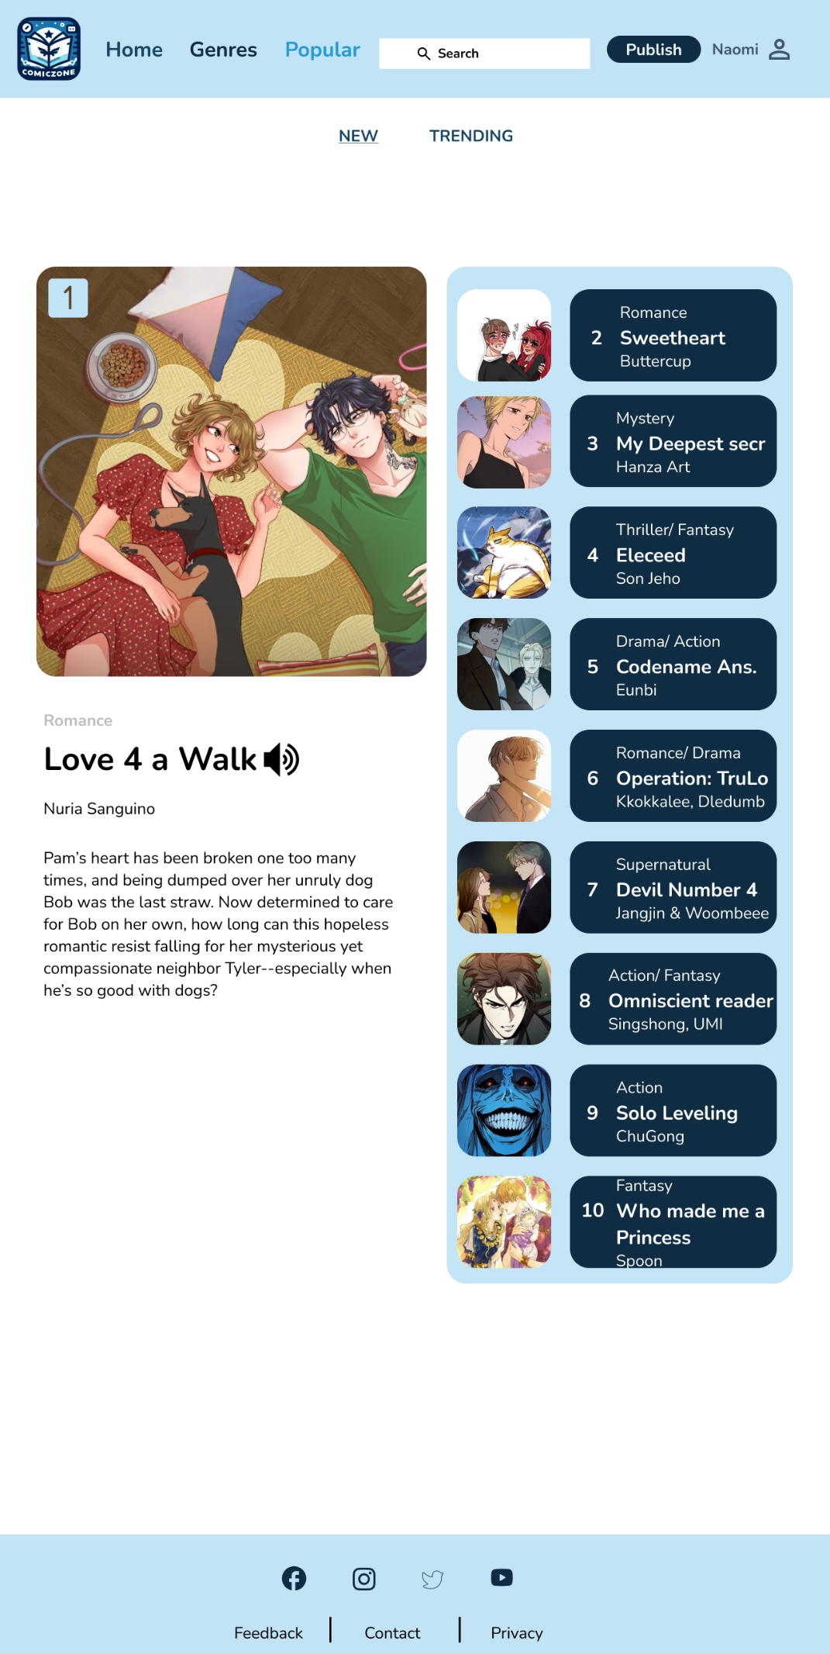

Figure 60 popular new

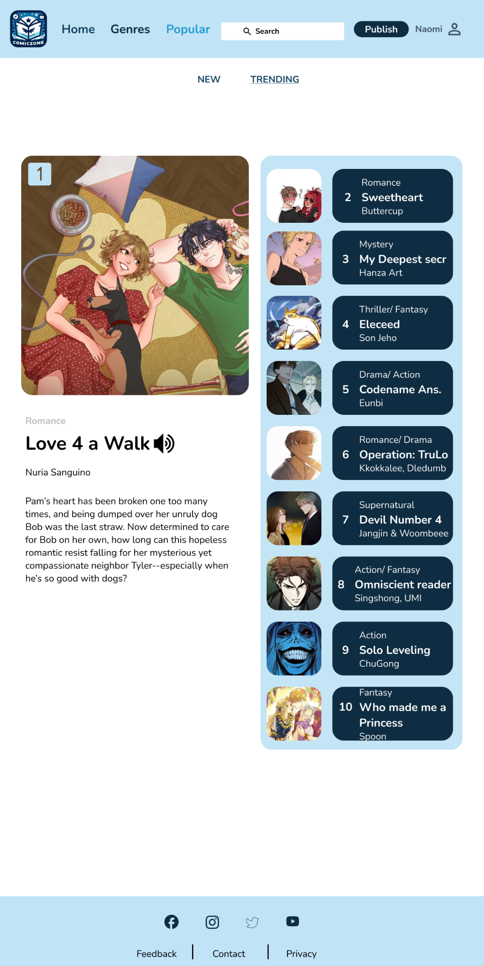

Figure 61 popular trending

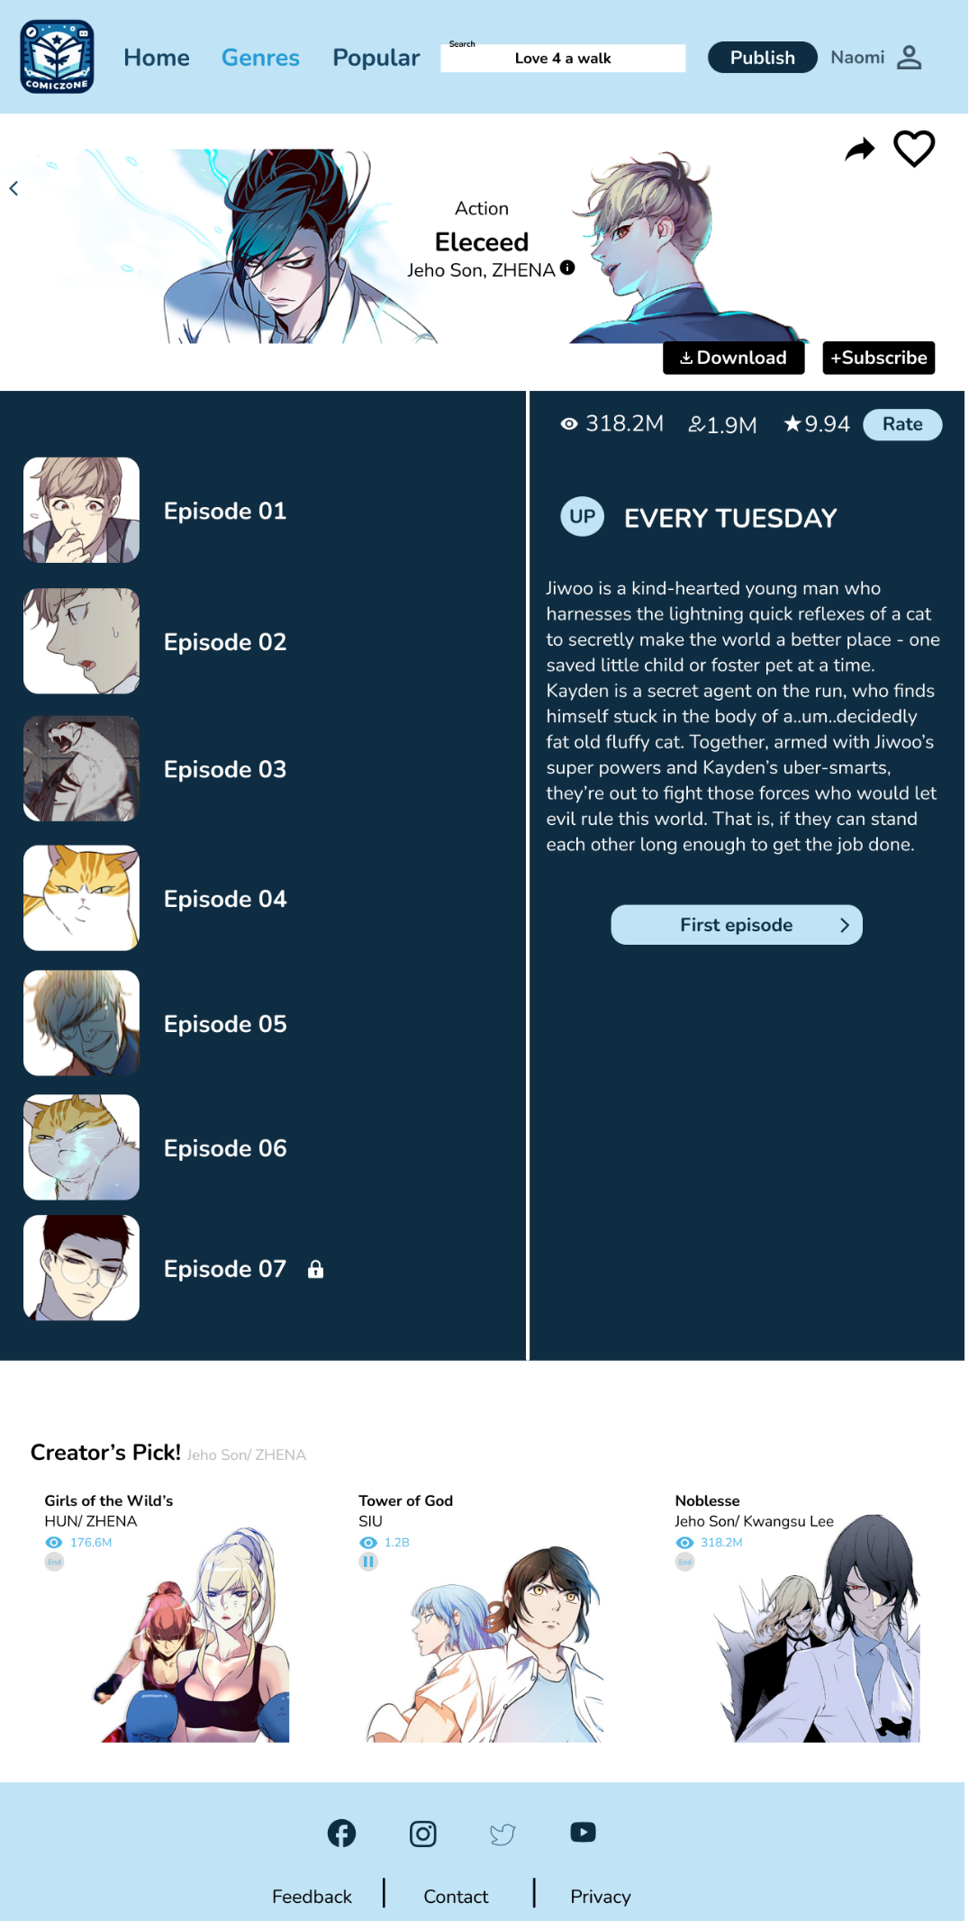

Figure 62 specific comic page



Figure 63 account setting

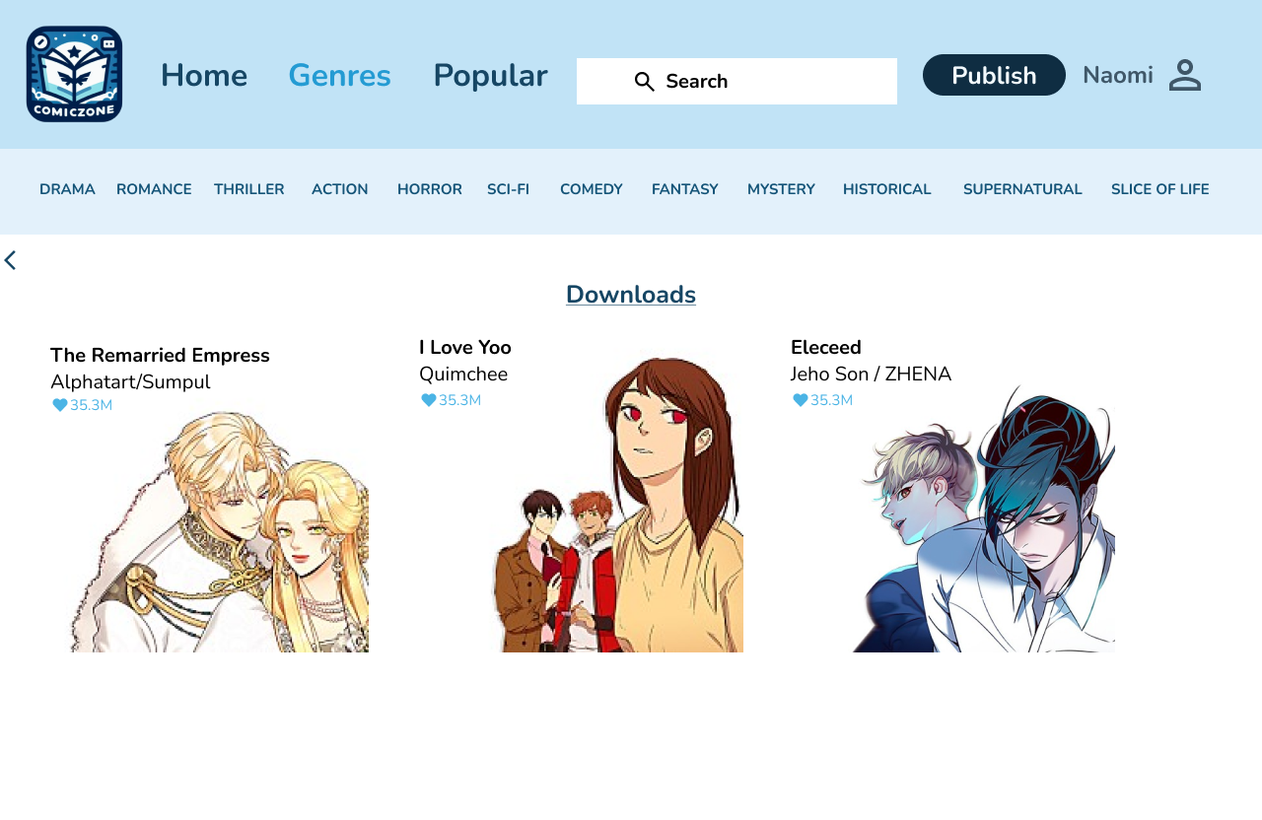

Figure 64downloads

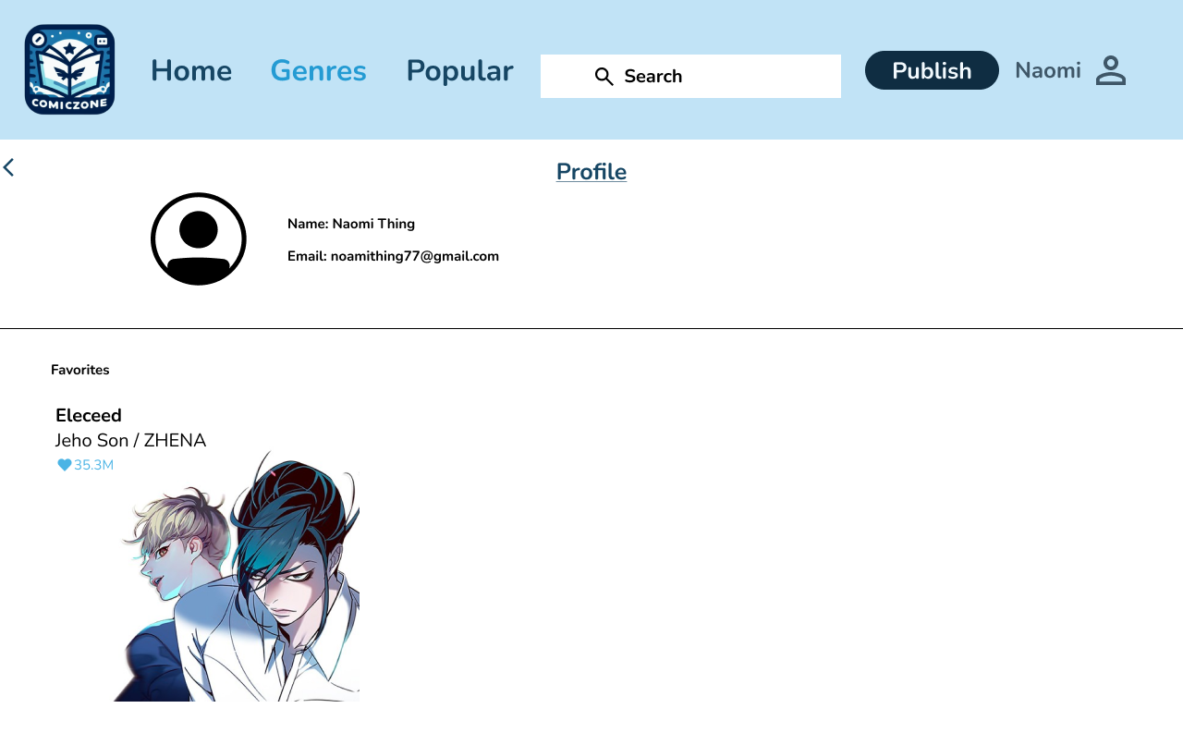

Figure 65 accoubnt edit and favs



Figure 66 content warning



Figure 67 unlocking chapter



Figure 68 with ad

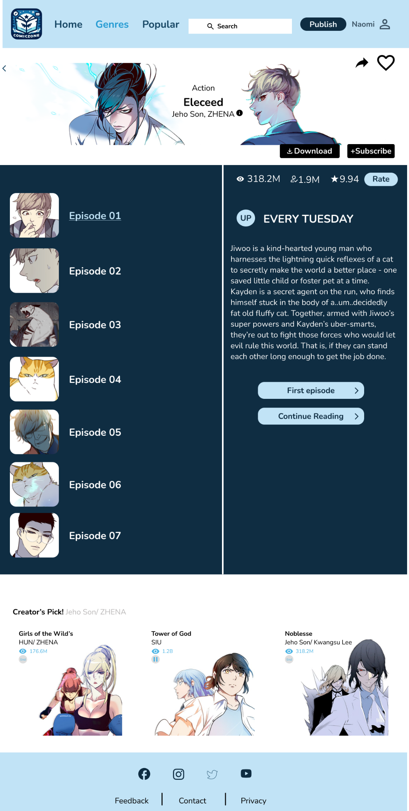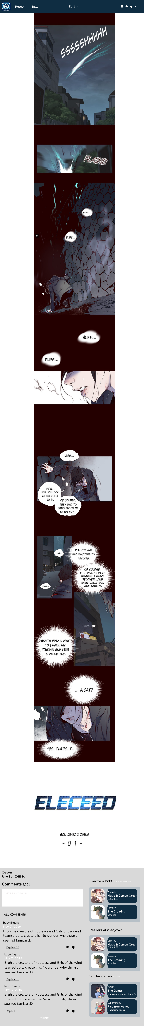

Figure 69 page after completion of 1 chapter



Figure 70 creators info



Figure 71 logging out

## Screenshot of Lo-Fi wireframes of ComicZone:







## 5.4 Prototype of ComicZone

Link to prototype of ComicZone: [Prototype of ComicZone.](https://www.figma.com/design/6LL7HHVvQehjfmhSArojVY/CZ?node-id=2%3A2&t=u7r8sX3HV7eYn2iL-1)